Mkdir dir1/dir2/dir3 - creates dir. and subdir.

Cd .. - move to parent dir .

Create hidden file – touch .file1 - when we use. Before any file it will be created as hidden file.

Ls –a – to show hidden files.

Mkdir .dir1 - create hidden dir .

Cp source destination – it will copy source to destination (both will be separate file)

Mv – moves file

Rm –rf – forcefully delete.

Rmdir – remove dir ; rmdir –p: remove parent dir ; rmdir –pv : remove parent dir along with vibrose .

Rm –r : remove empty directory:

Hostname: to get to know about system information.

Ifconfig : To check Ip in Linux and ipconfig in windows

Hostname -i: to check only Ip .

Cat /etc/os-release : this is absolute path . This will give os version .

Yum – is used to install uninstall software's in linux .

Yum install httpd –y : this will install apache software .

Yum remove httpd – to remove apache .

Yum update httpd – to update apache .

Service httpd status / start / stop – to start stop appache .

Chkconfig httpd on/off – it will start apache yb defualt withour manul intervention

Whoami – to check user

Which – to check softwares installed .

/usr/bin > then run - **Which –a chef /gitlab-ctl / jenkins**

**Echo –**to print message .

Echo “hi” > file : it will create/append file with the message .

Echo > file – this will delete content of file .

Grep – to search specific items in dir / file

Grep search-word /dir-name-to-search/file-name-to-search

Sort – file will be arranged in alphabetical order .

Less -

More -

Head – to view start 10 lines

Tail – to view last 10 line

Useradd abc – creates user .

Cat /etc/passwd - user will be added .

Groudadd new – create group

Cat /etc/group - shows group

When we create user without group , group will be created automatic , but reverse wont work .

Gpasswd –a user-name griup-name :– to add user to group .

Gpasswd –m user1, user2 , user3 grp-name : all user will be added to group

Hardlink : for backup : **ln**  - it will create link that will copy file regularly . ln file-name backup-file : if wee add anything in any of the file same will be copied in abother . But if we delete any file other copy will exist.

softlink : create shortcut -: **ln –s** file-name softfile – softfile will be SoftLink for file-name .

Tar –c(create) v(verbose) f(force) tar-dir-destination dir-name-source

Tar is an archive used to combine multiple files to one.

We can zip tar using gzip .

Gzip dir-tar – it will compress tar.

Gunzip dir-tar

Tar –x(extract) vf dir-tar – it will extract all files.

Wget – used to install software.

Wget URL

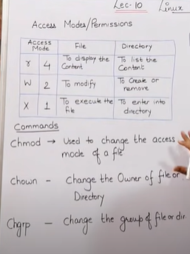

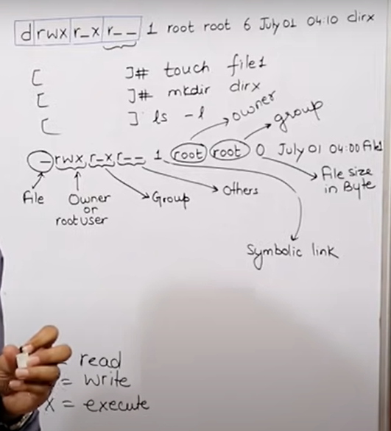

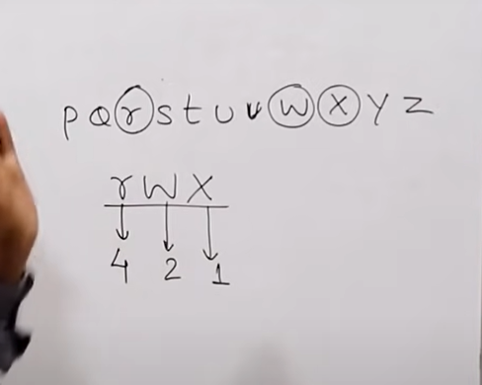

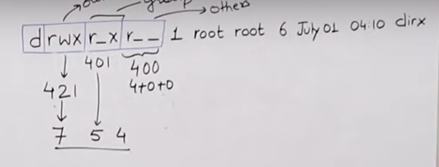

If we want rwx for all .

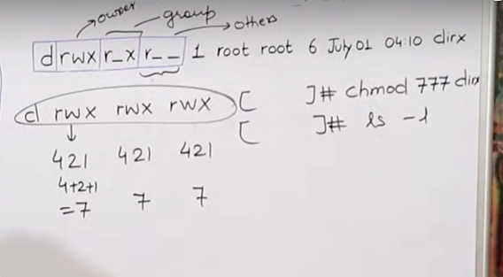

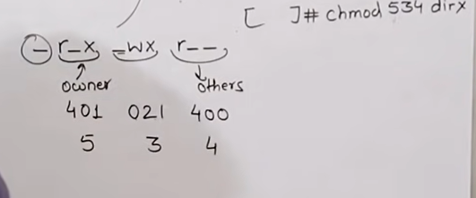

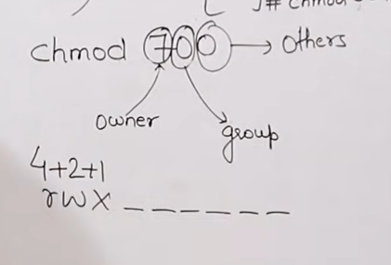

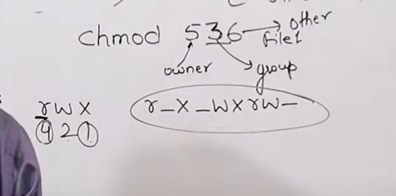

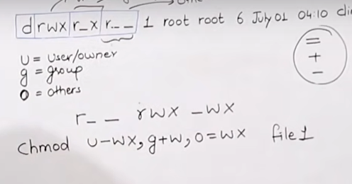

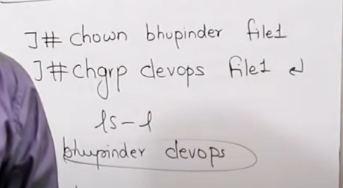

GIT:

Software configuration management / source code management: Multiple developers work on mutiple features. Previously moving code to others was manual, in SCM – we have manager that maintains history of all changes done by developers.

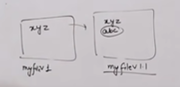

Managing mutiple versions of code –SCM

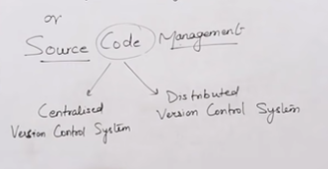

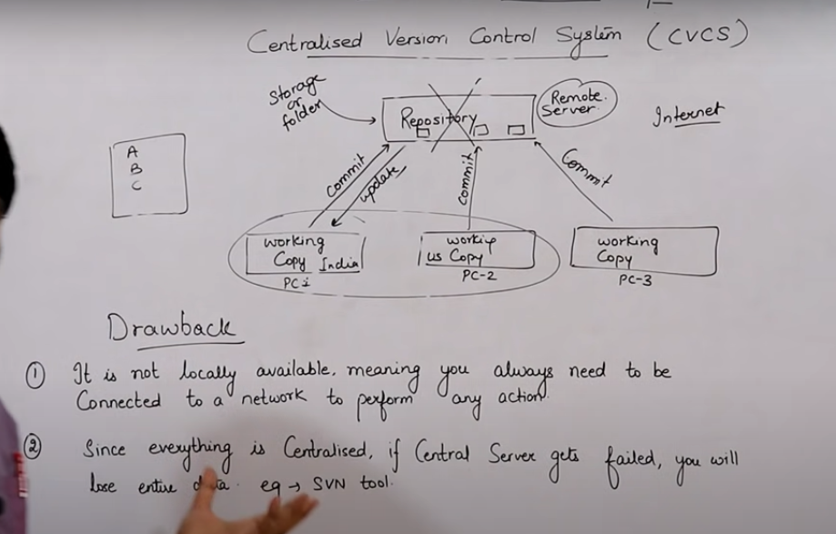



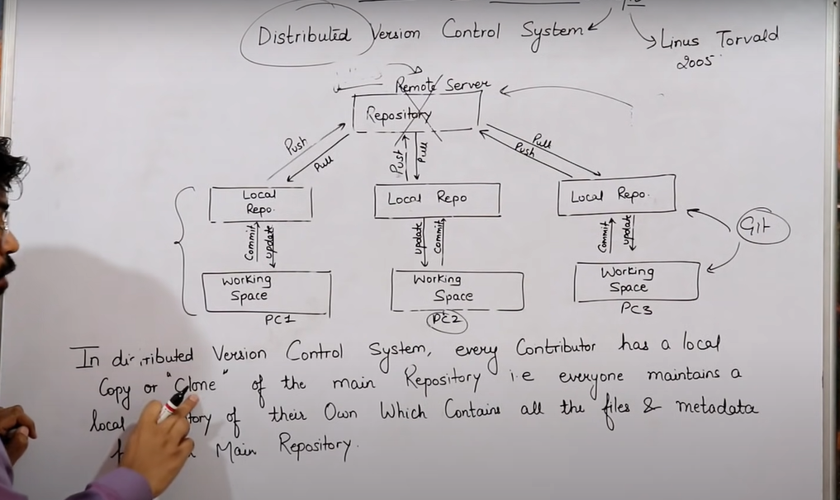

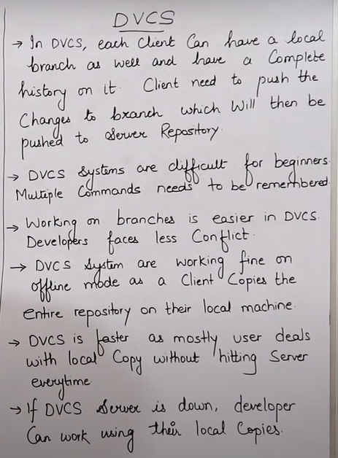 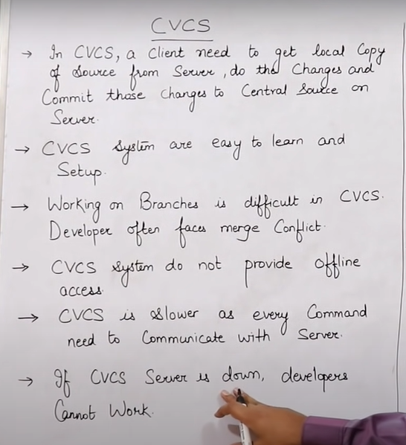

Git init – initializes git in directory. - dir will be converted to local repo.

Stages: Working dir / working space (we will add code); staging area (move from working are to staging using git add); local repo (commit – save – snapshot) -

CHEF: Configuration management tool.

System administrator – task is to manage multiple servers with Mutiple os . Maintain servers.

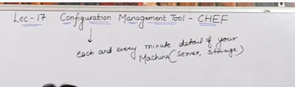

Cconfiguration management means managig muktiple infrastructure using tools .

CM tools are of 2 type – push based and pull based .

CM tools is part of OPS .

IAC : tasks like giving ip to machine or installing softwaes can be automated .

Push configuration server pushes conifguration to nodes . - eg : ansible , saltstack .

Pull based – pull conf nodes heck with server peridicaly and fetches the configuration from it. - eg chef , pupet .

In push based – control is in our hand .

In pull based – configuration of new machines tales place continously .

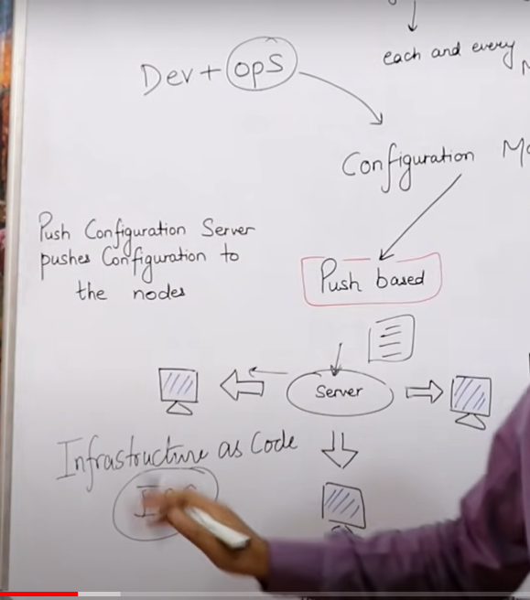

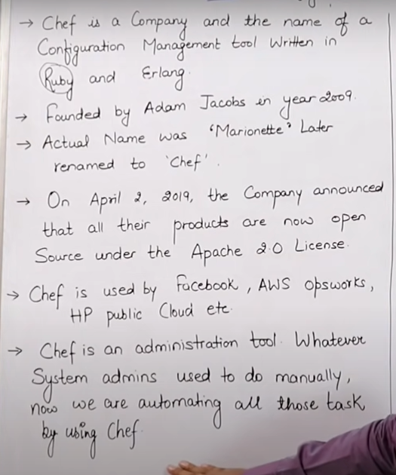

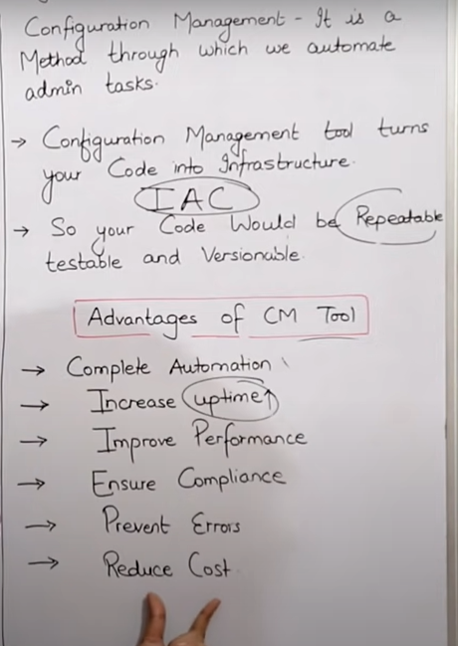

Cookbook – place where recipes / codes are placed in chef ; collection of recipes .

Cookbook is uploaded inchef server .

Knife pushes cookbook from workstation to chef server

Bootstrapping is process by which chef server connect to nodes to performs task .

Chef – supermarket : we can find multiple cpokbooks

Node – chef will be installed in workstationa nd node both .

Node is chef client .

In node – chef client and ohai is present .

Current configuartion of machine is stored in ohai .

Chef-cleint first takes update from ohai In node server then moves to chef server .

Idempotency - don’t repeat same thing again .

Ohai is a database which stores current cofniguartion of node and if recipe / cookbook has some new update then it will be pushed to chef server and after which node server will be trigered to pull the update for chef server .

Workstation – where we write code .

Server – chef – where we sore code

Node – where we apply code .

In chef cookbook is written in ruby language .

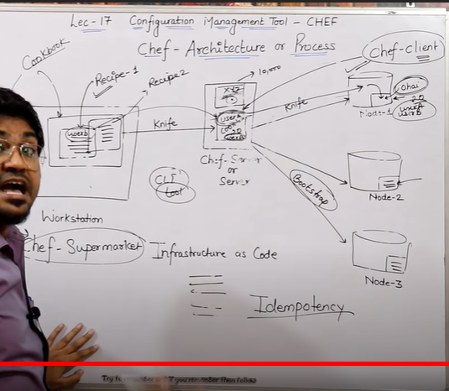

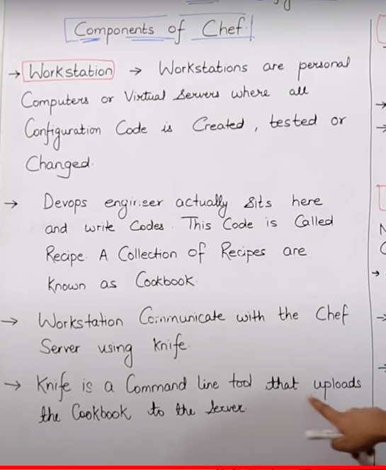

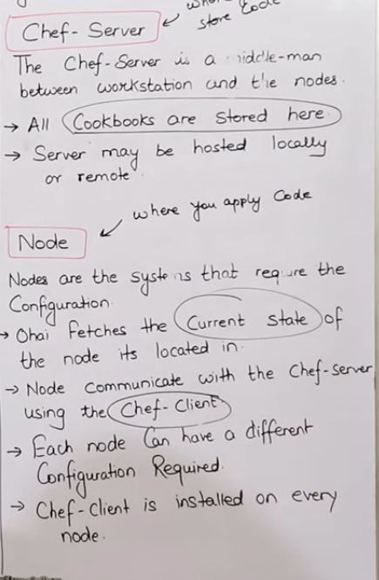

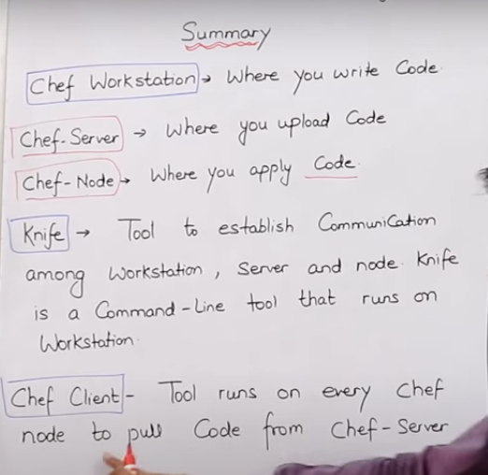

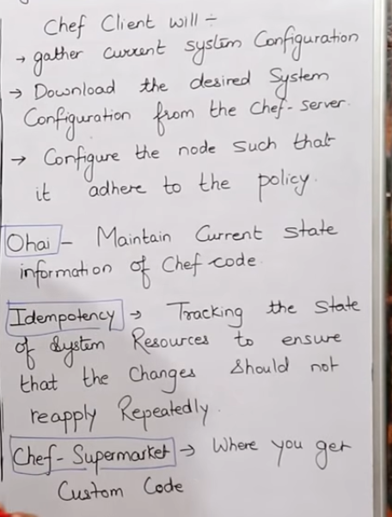

Creating cookbook and recipe:

In linux we will install chef workstation.

NOw create dir named: mkdir cookbooks – inside this create different cookbooks eg : test-cookbooks and in that recipes will be stored.

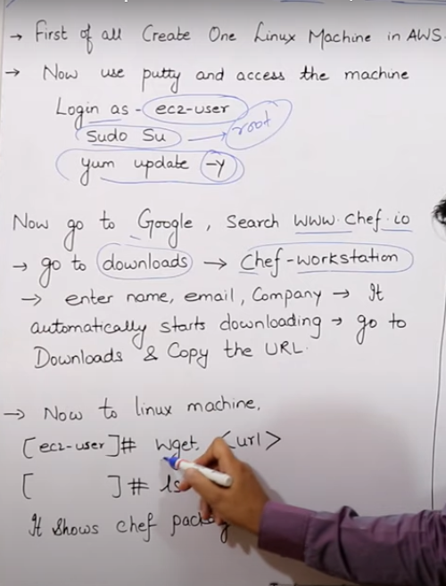

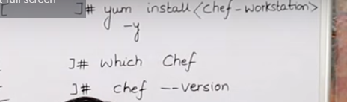

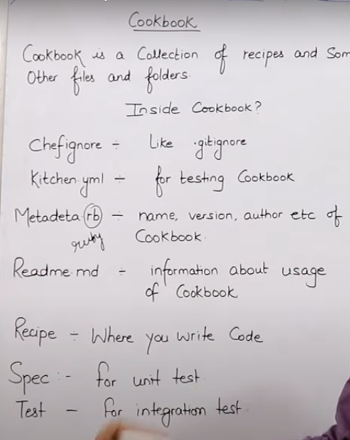

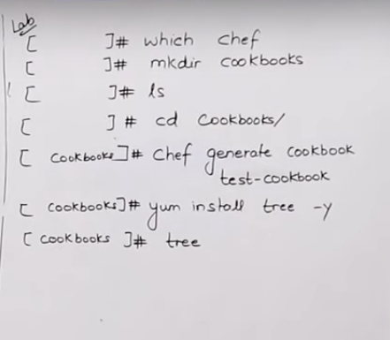

We can create cookbooks and recipes using

Chef generate cookbook cookbook-name

Chef generate recipe recipe-name

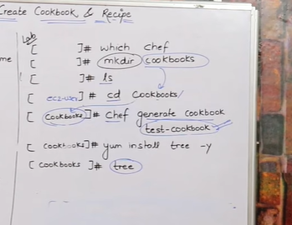

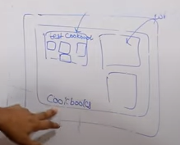

Tree – check whether cookbook is created or not .

Tree command give list of cookbook and recipes .

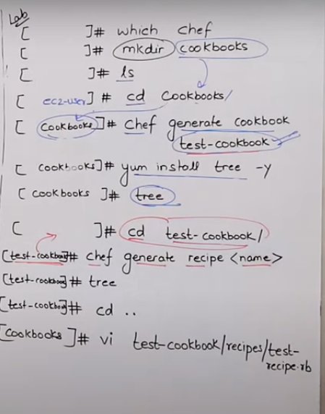

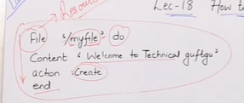

file '/myfile' do

content 'Welcome to Technical Guftgu'

action :create

End

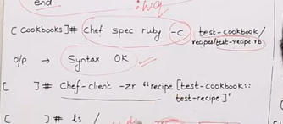

Chef-client will first check in ohai whther the particular recipe is present in database or not . IF not then it will pull the recipe to ohai and then run recipe in node .

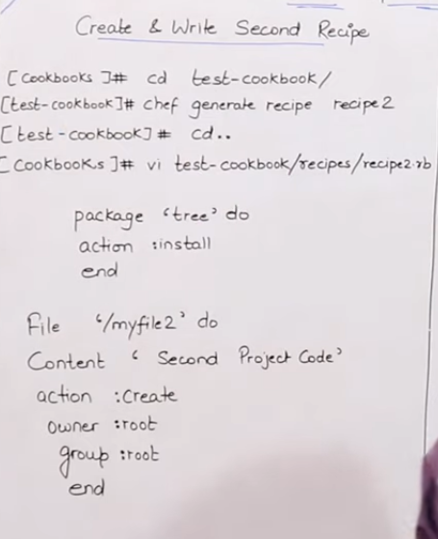

Recipe will always be created inside any test –cookbook

package 'tree' do

action :install

End

file '/myfile2' do

content 'This is My Second Project code'

action :create

owner 'root'

group 'root'

end

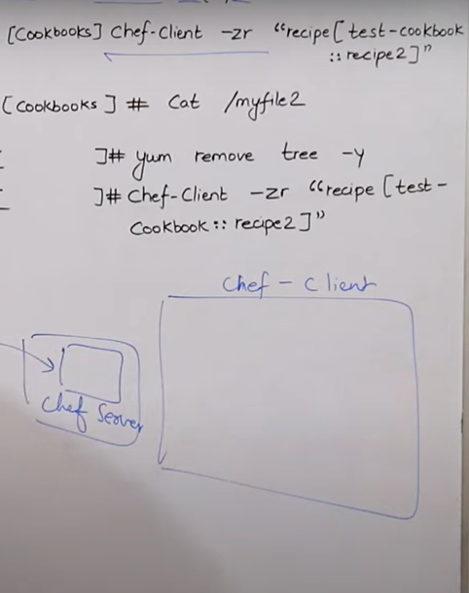

Chef –client will check ohai and pull recipe from workstation .

Since tree is already insalled we will get up to date but file will get created .

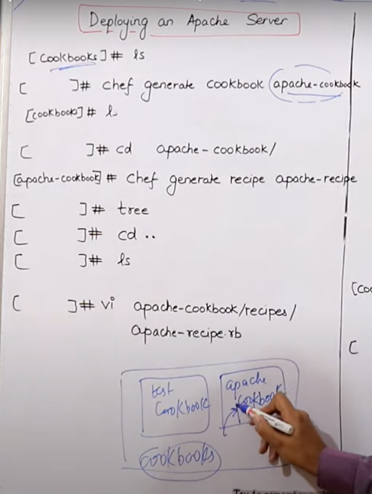

Always use .rb in end of recipe name while making changes to recipe file using vi .

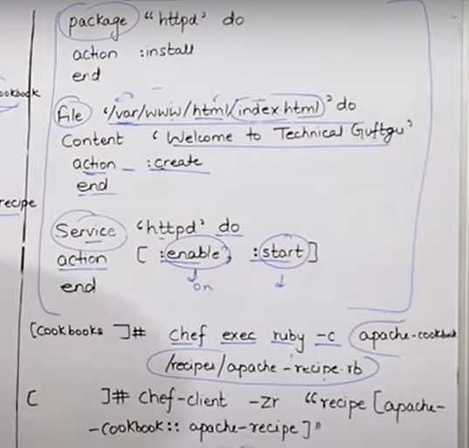

If any of task listed in recipe is already done in node thwn we will get up to date rest task wil be performed .

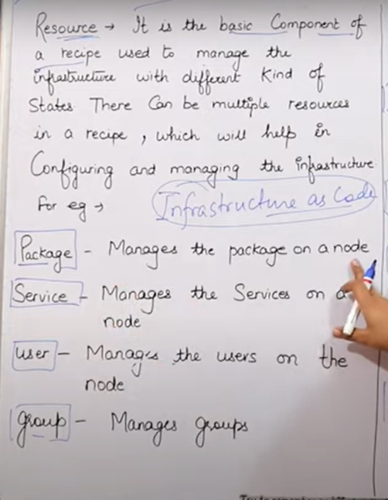

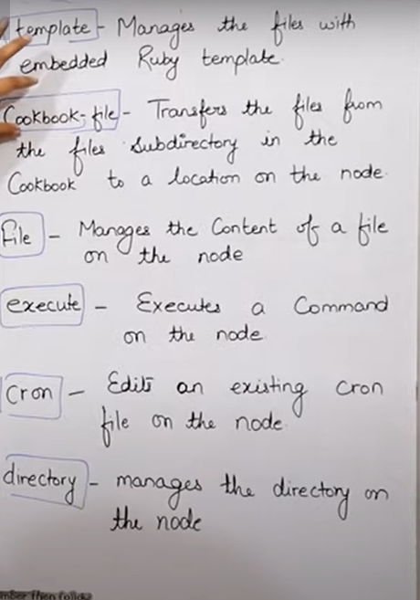

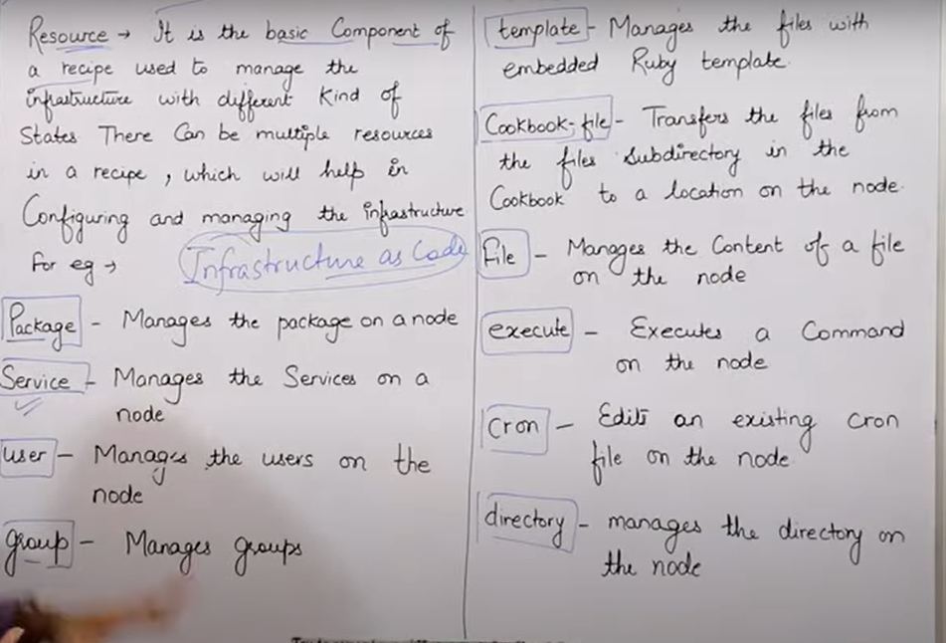

Port for http: 80

Port for ssh : 22

Go to download.chef.io and install chef workstation.

Wget package-url- once rpm downloaded

Yum install .rpm

Chef –v

Mkdir cookbooks

Cd cookbooks

Chef generate cookbook test-cookbook

Cookbook will be created .

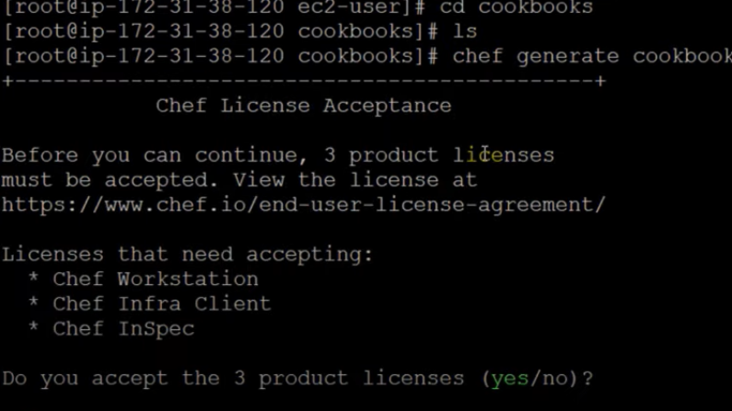

Tree to be installed

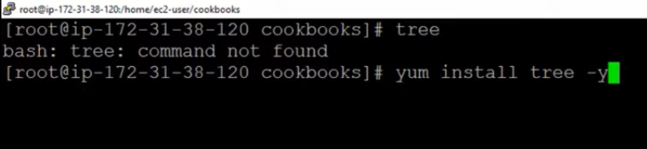

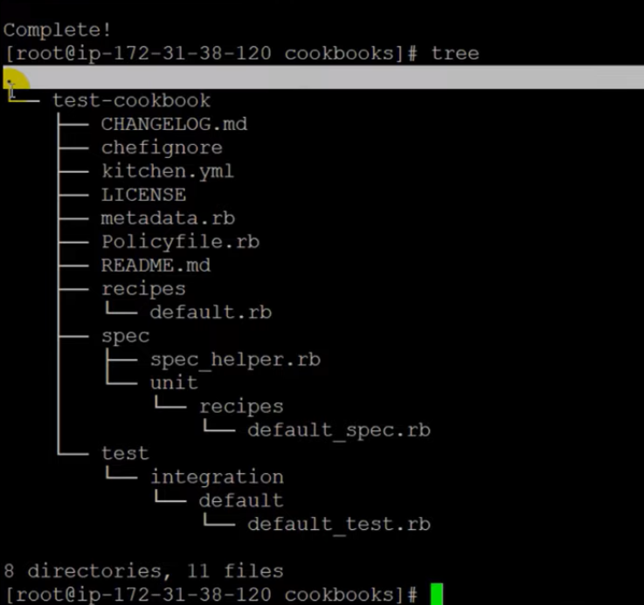

Tree command shows all cookbook hierarchy

Cd test-cookbook/

Chef generate recipe test-recipe

Now with tree we can view our recipe .

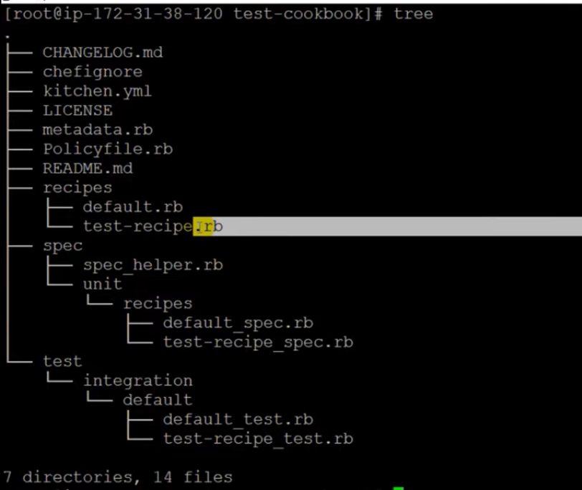

Open recipe file :



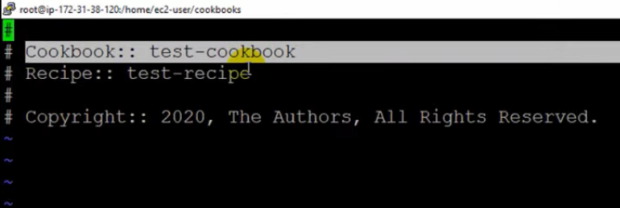

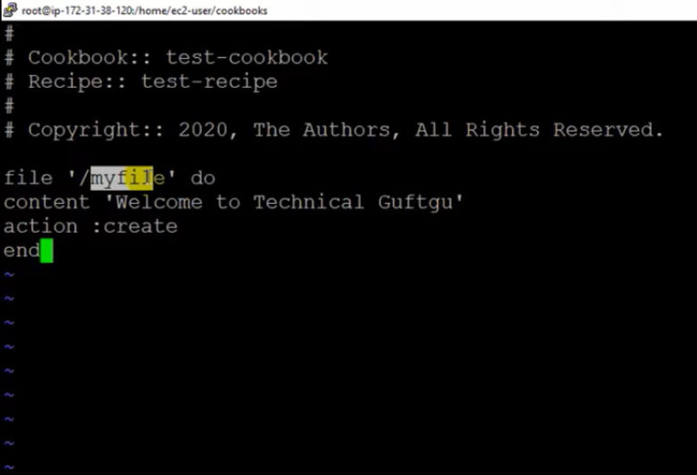

Once code written in recipe chef exec ruby –c : to check syntax of recipe



Once sytax check done we can run our recipe :

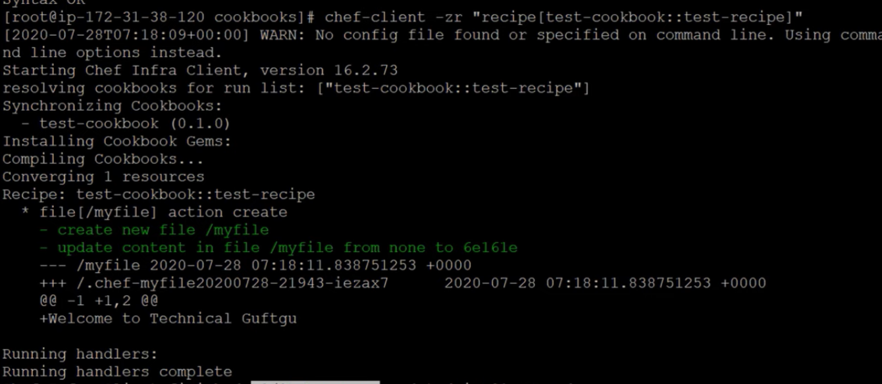

We can update the recipe file for changes anf then run chef-client to aply changes .

Chef generate recipe recipe2

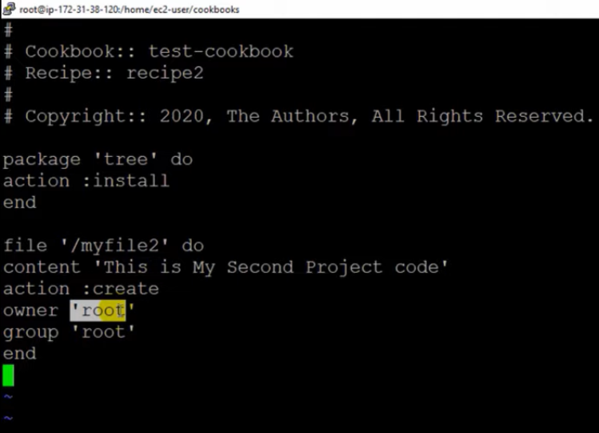

Add the code to recipe book .

Chef exec

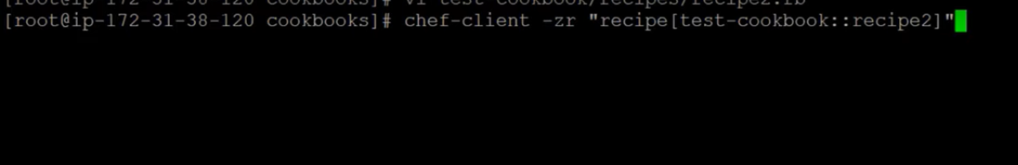

Apply changes

Once done

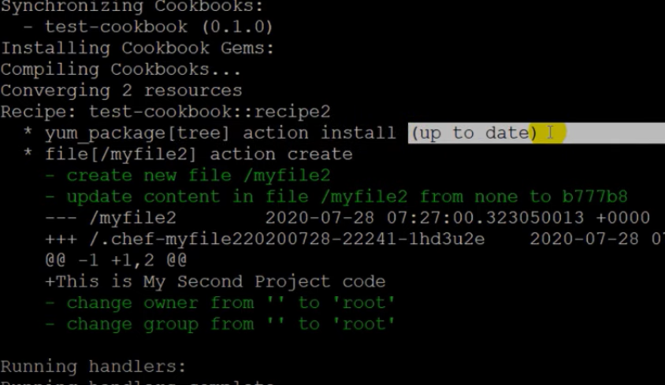

Cookbook for apache server :

Chef generate cookbooks apache-cookbook

Cd apache-cookbook

Chef generate recipe apache-recipe

Vi /....../apache-recipe.rb

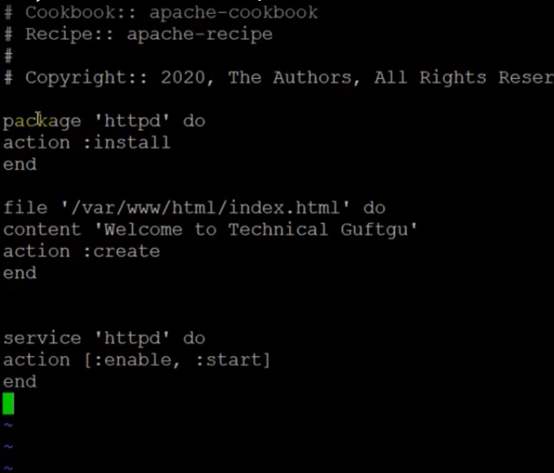

Syntax chefck:



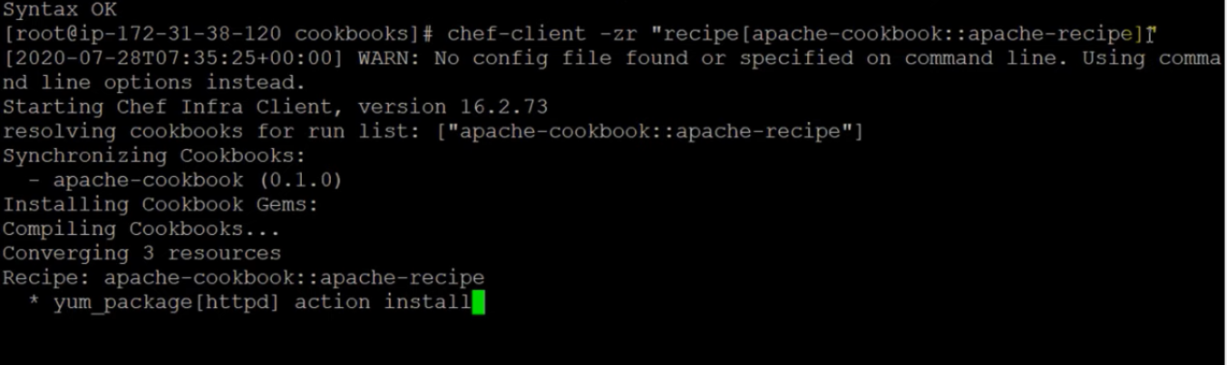

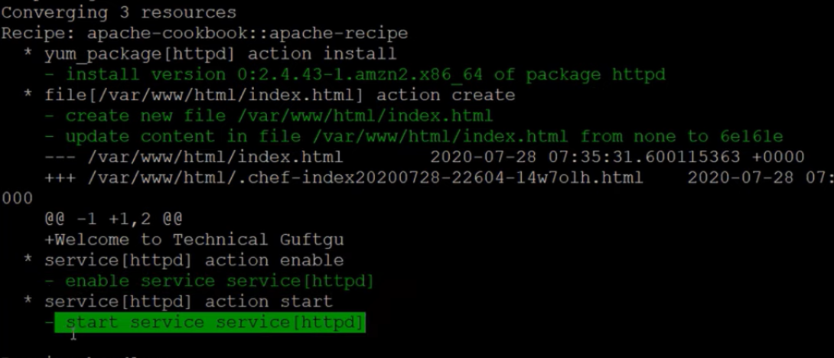

Chef attribute

In chef we have key and value .

We use key to define repeatable words or task .

We can change value of key as per requirement .

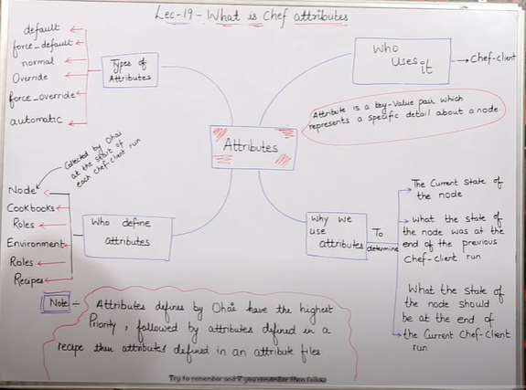

Attributes are stored in ohai .

Chef client will check current key attributes in ohai .

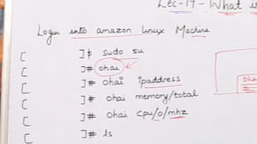

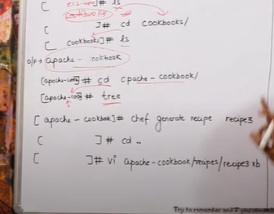

Once recipe3 recipe created move back to cookbook dir

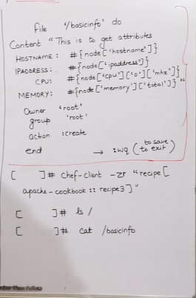

Enter above code to recipe3 using vi

The above code will give corresponding configuration related to the node in which we run code .

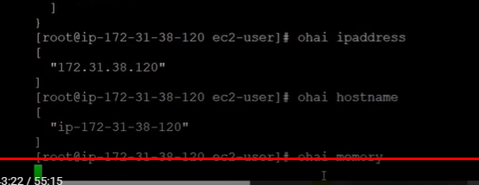

We want in output

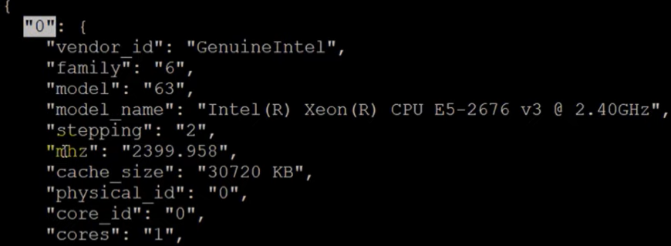

Cpu / 0 / mhz

We can write in command as

Ohai cpu/0/mhz

Chef fenerate recipe recie-name

Tree

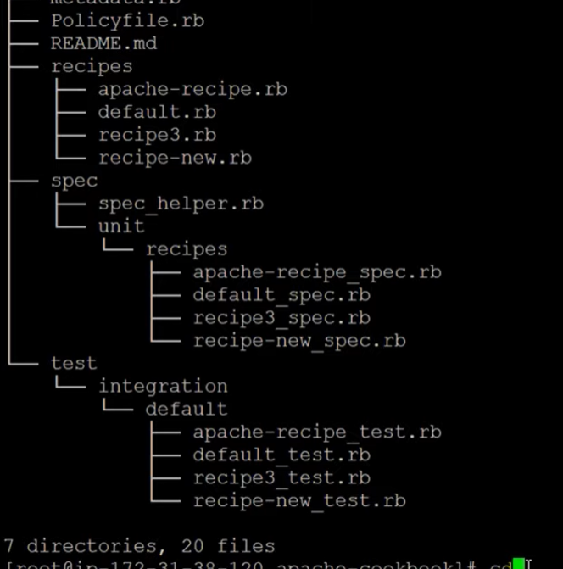

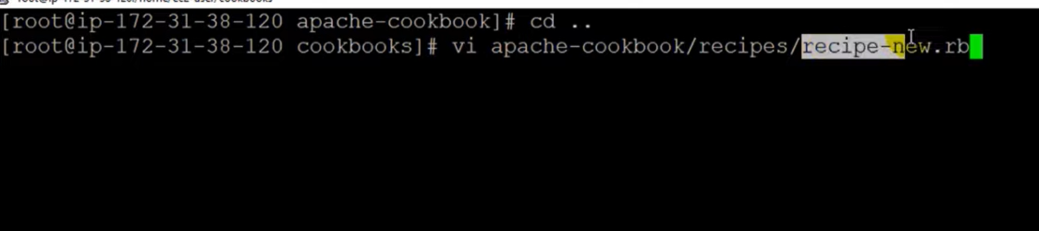

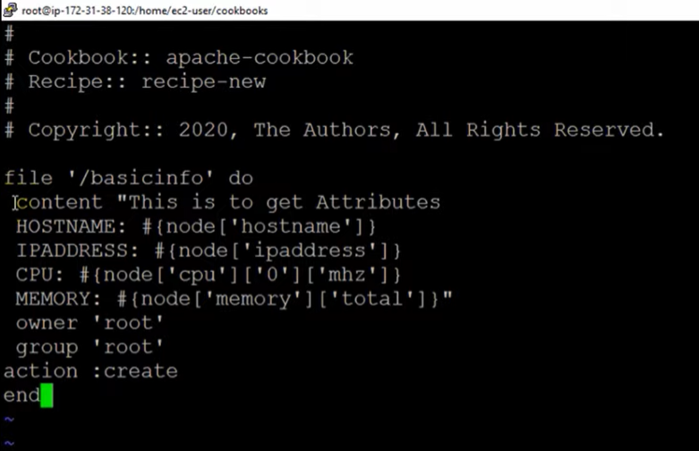

Chef-client –zr to apply recipe



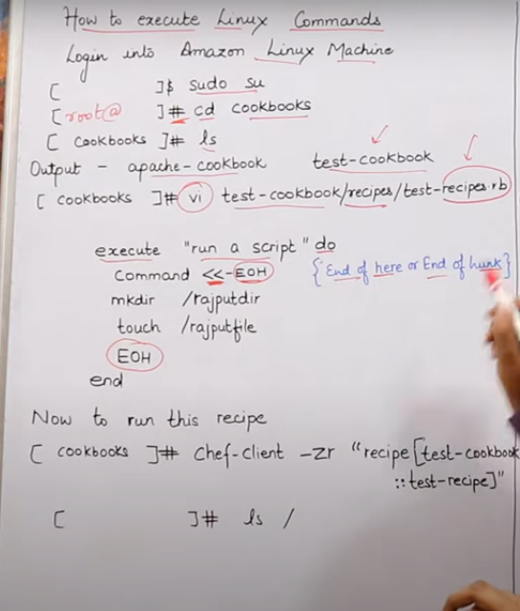

To run linux command in ruby script we can use : command << ~EOH (end of here or end of hunk)

In EOH – we don’t have idempotency , linux commands will be repearted in each exec chef-client .

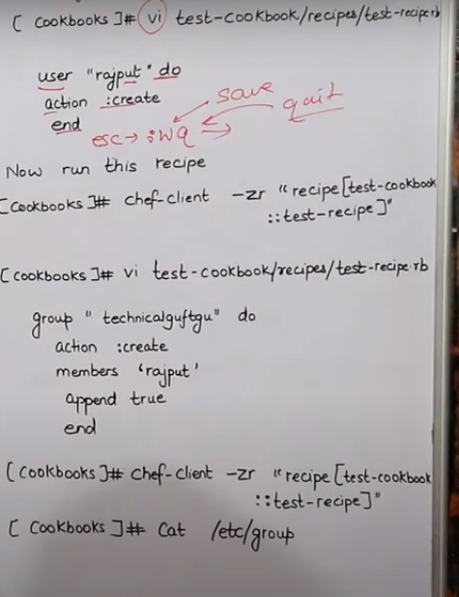

Append true will append the user to existing user , if we don’t use append then it will overwrite existing user .

Cat /etc/group - a;; group of linux machine will be present .

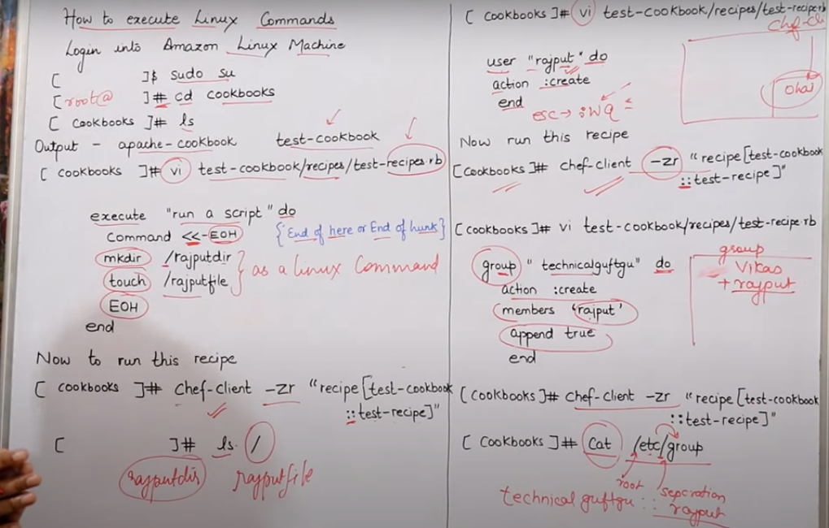

Convergence – chef –client will first check in ohai for the recipe later will pull recipe if chages observerd .

We can run multiple recipes in using cookbook but only 1 recipe of 1 cookbook .

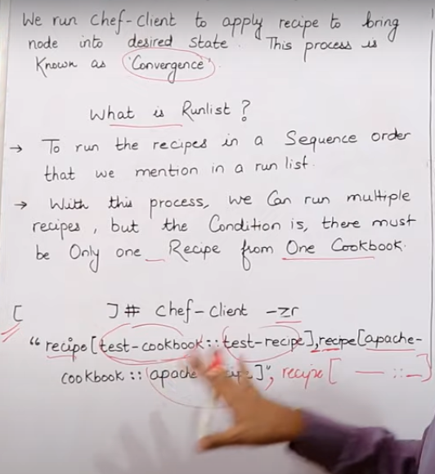

We can also run multiple recipes of single cookbook – we need to use include_recipe in 1 recipe.rb file .

`

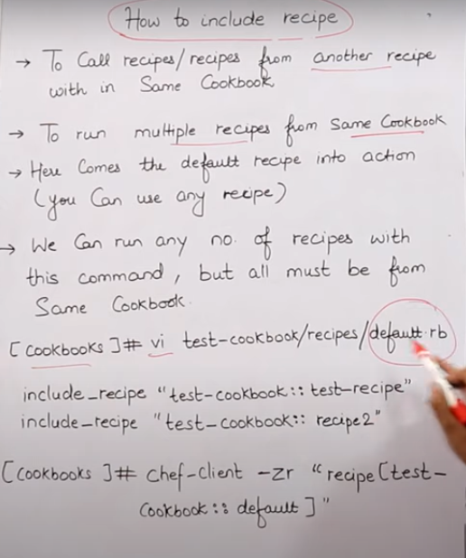

We can also run multiple cookbooks recipes togeather .

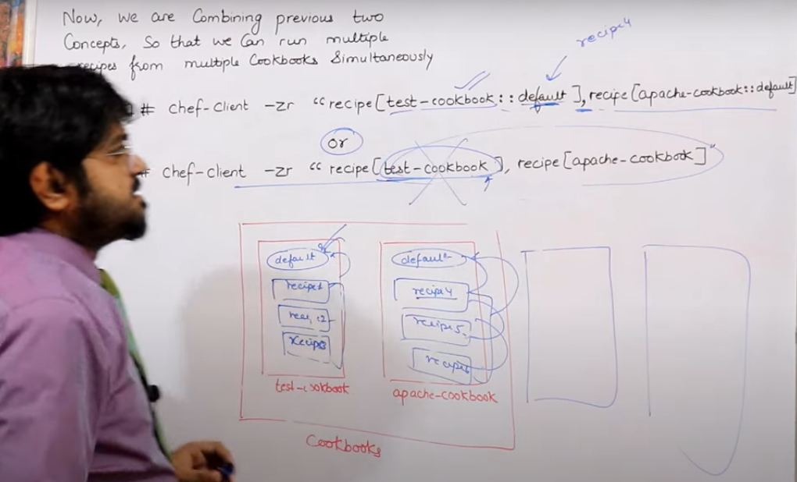

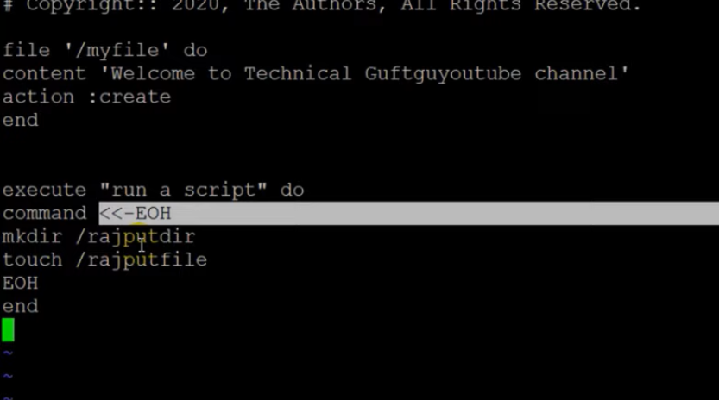

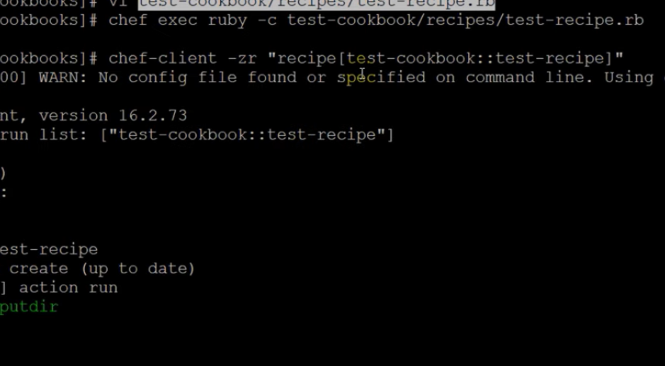

Linux command will be excuted everytme we run chef-client

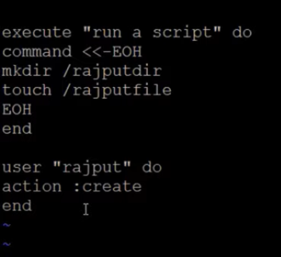

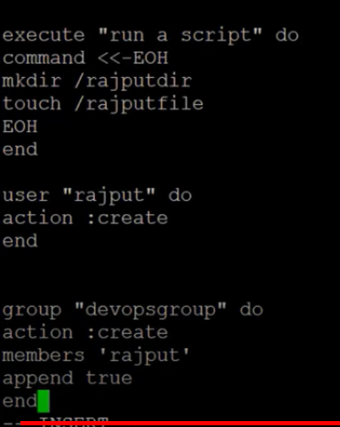

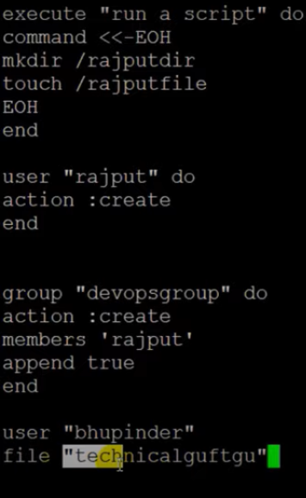

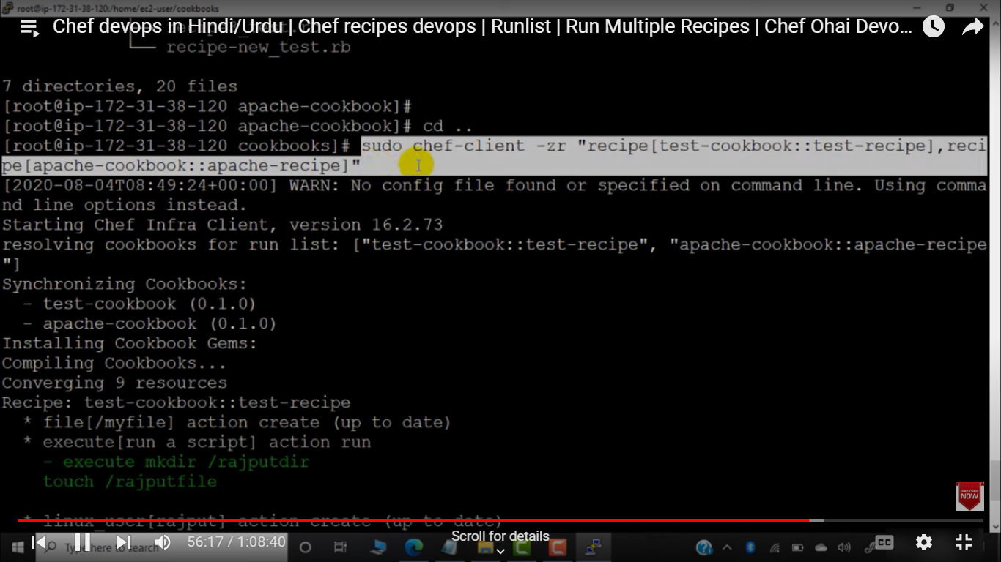

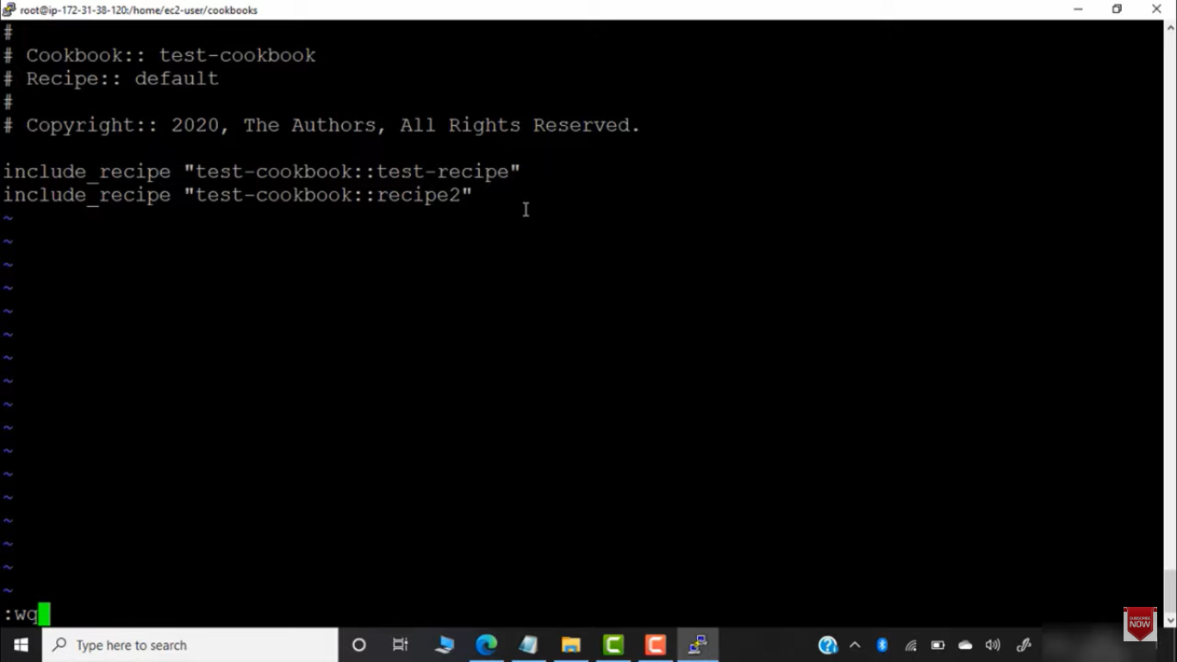

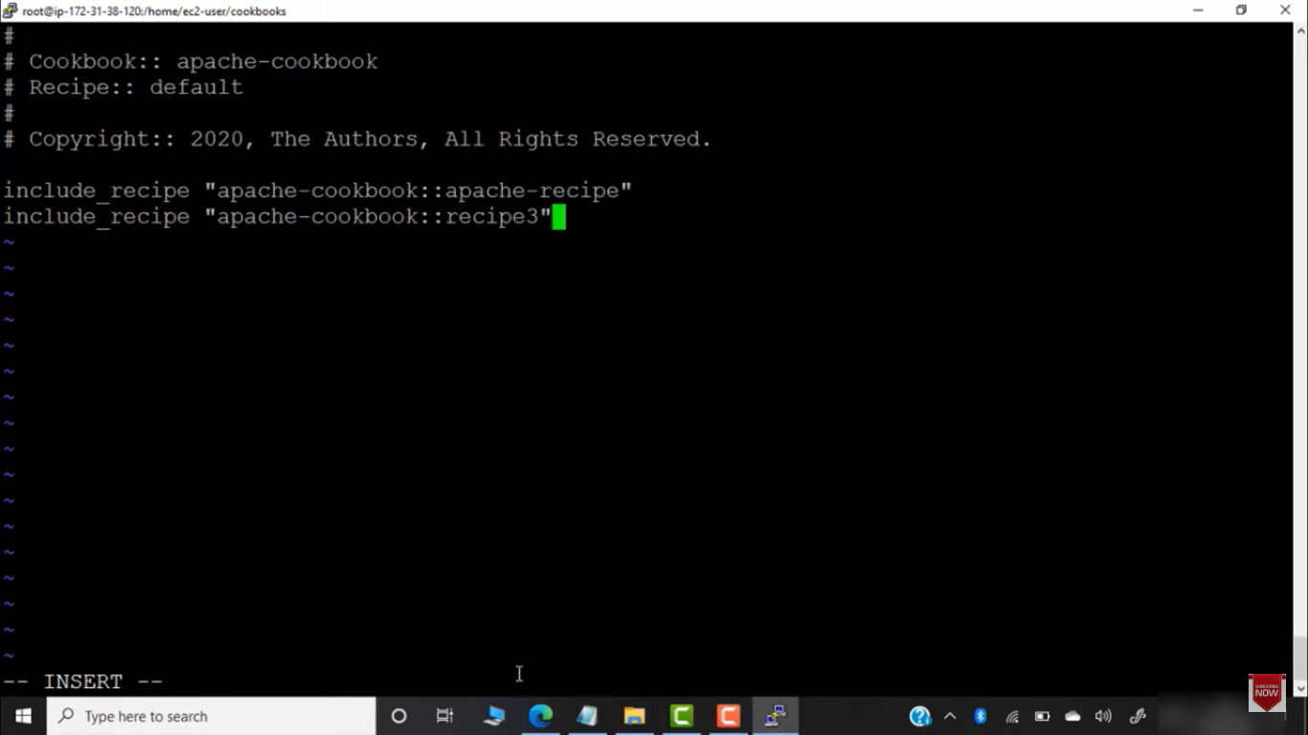

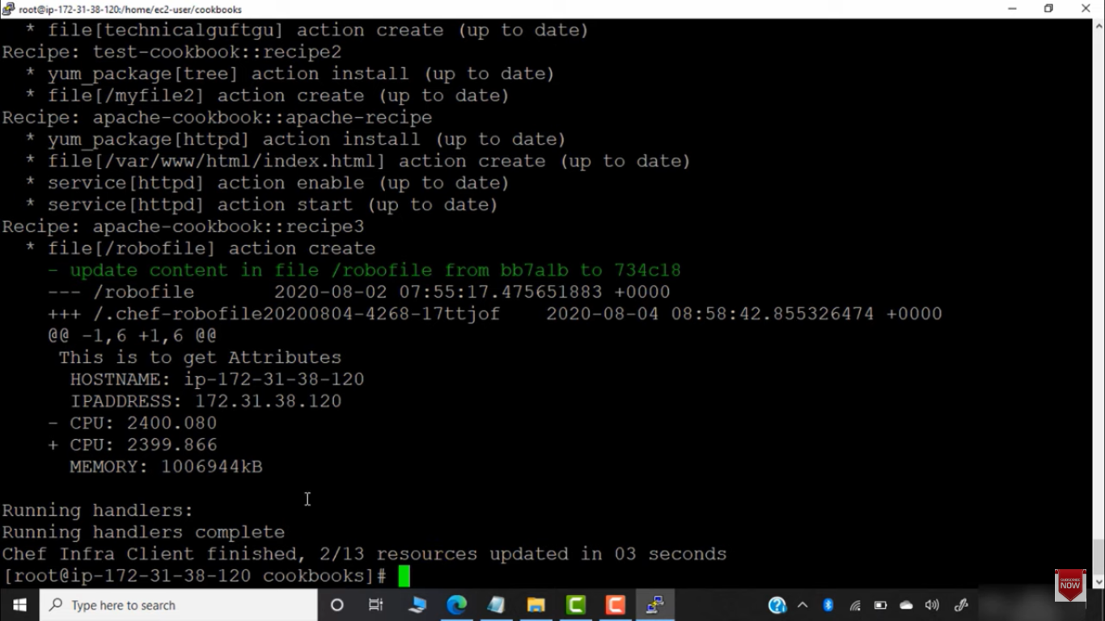

In above example we used 2 cookbook recipe and both cookbook had include_recipes .

Bootstrapping in chef :

We have workstation , chef-server , nodes .

We don’t directly access chef-server , we work using workstation .

We can connect workstation to chef – station .

After that chef-server will be connected to nodes – process is known as bootstrapping.

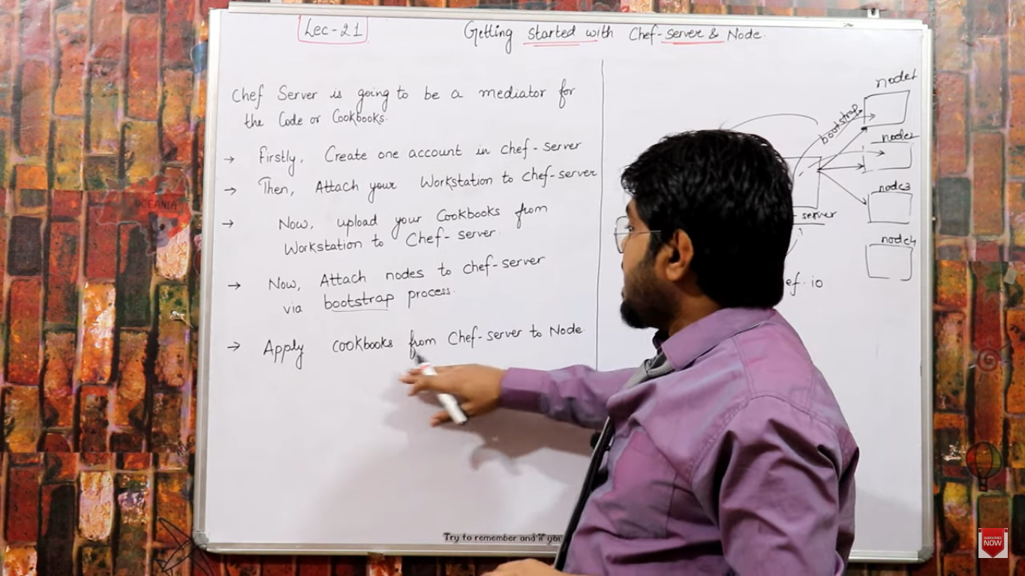

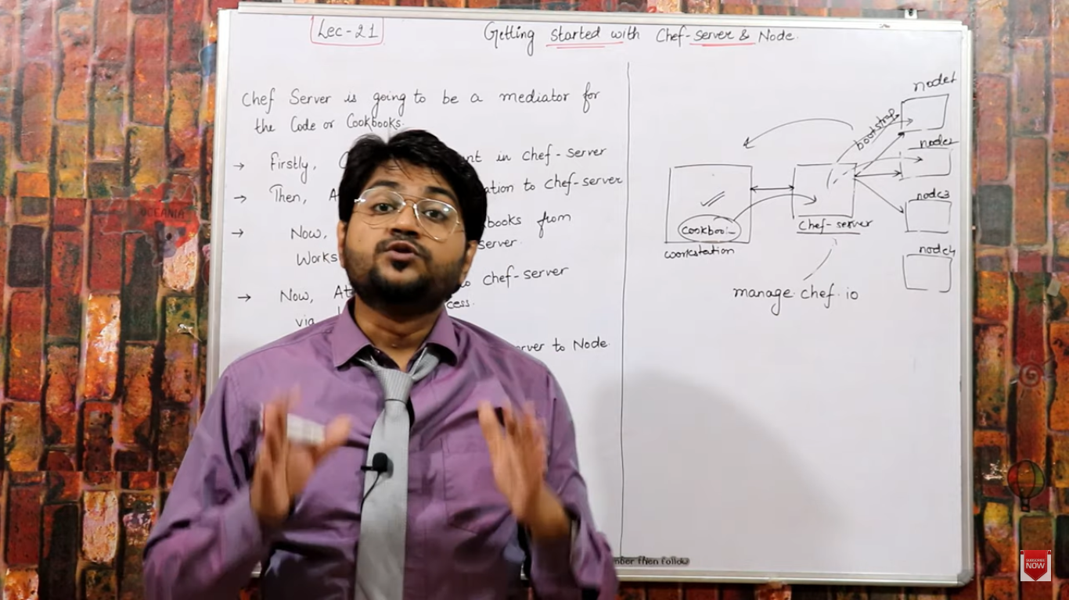

Node can update thenselve with latest cookbook from workstation .

Connecting workstation to server .

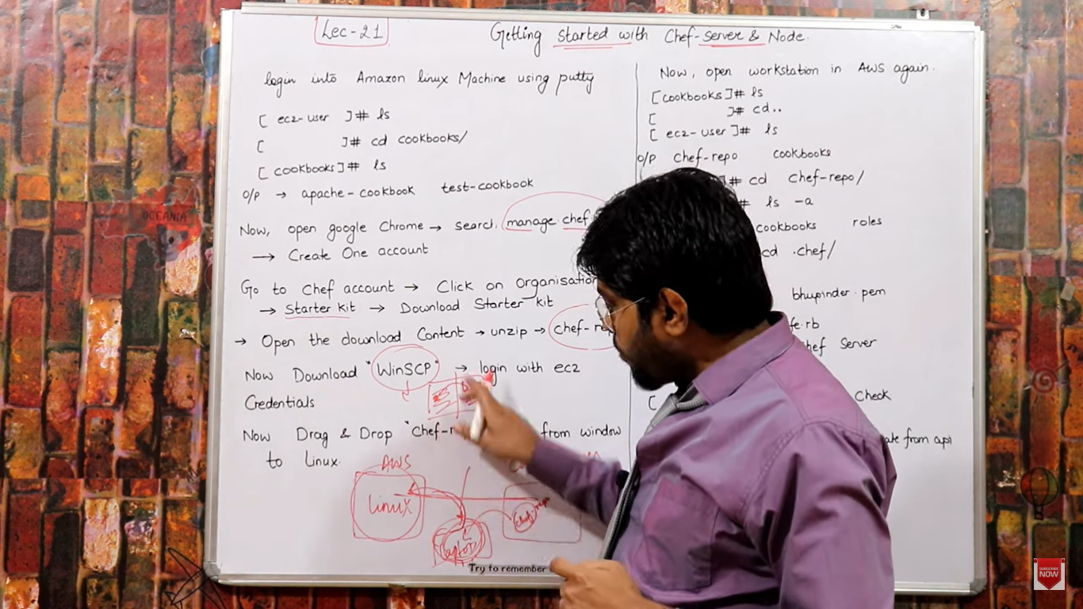

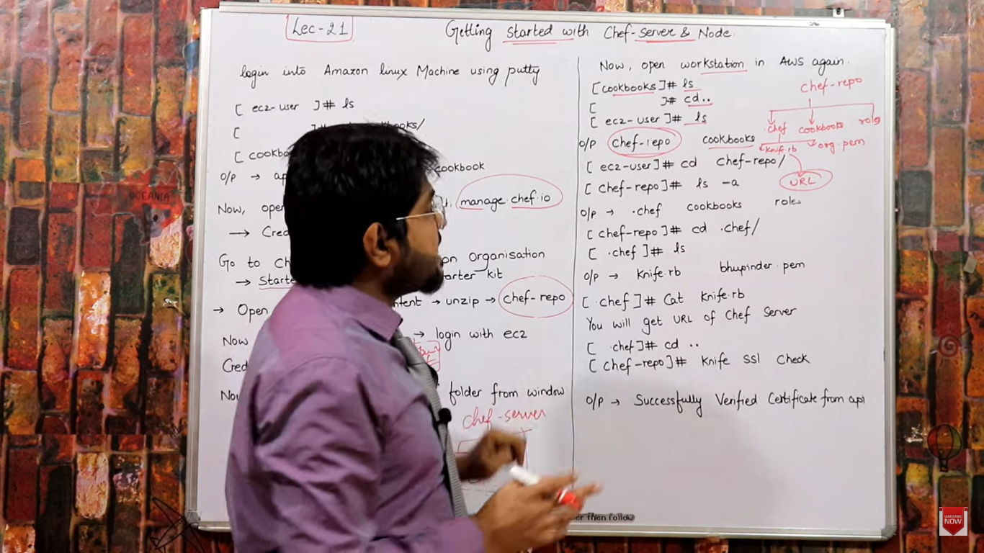

Fisrt login to workstation :

Go to manage.chef.io

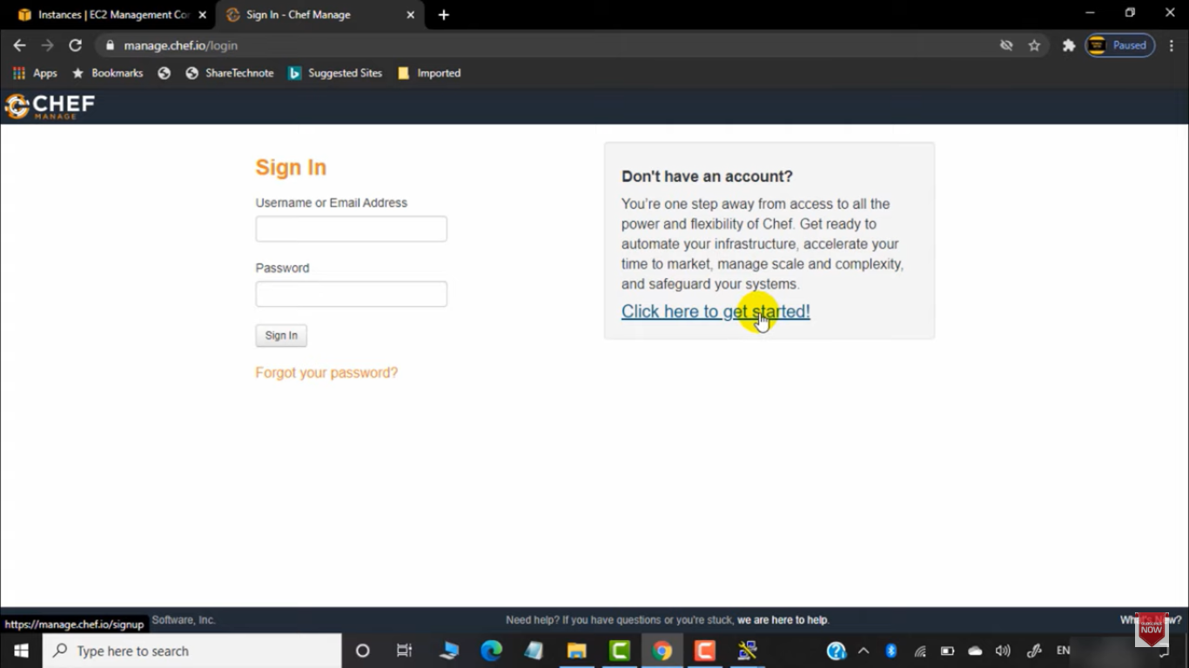

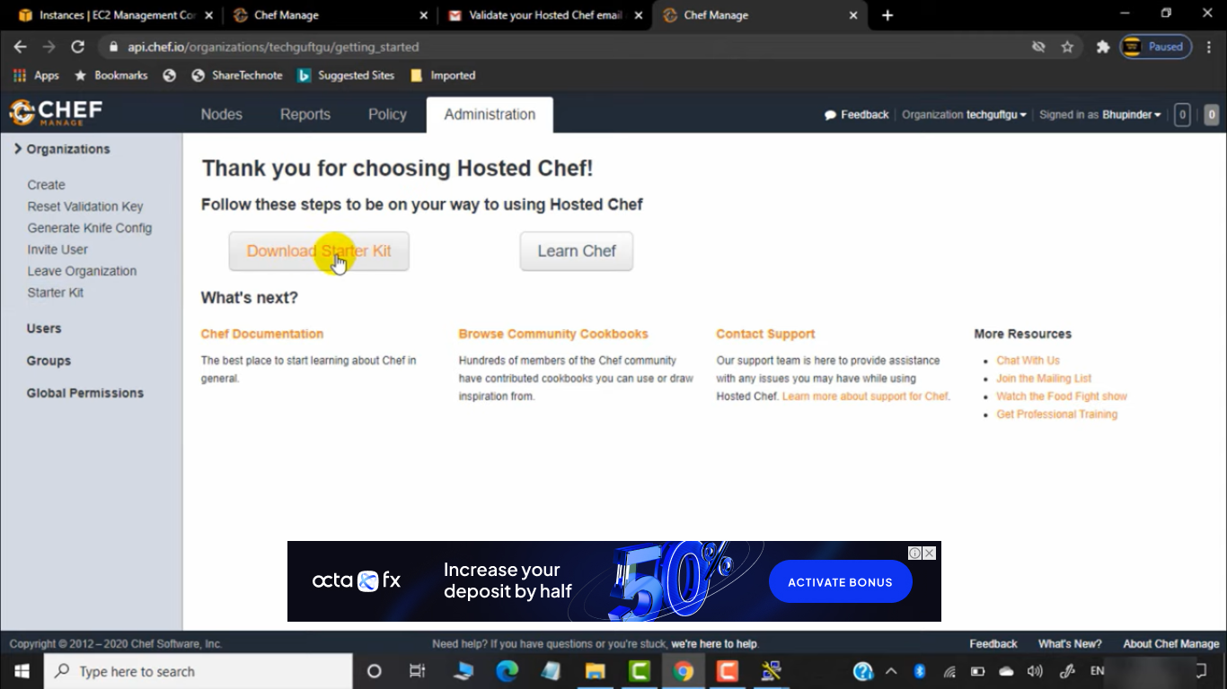

Download starter kit .

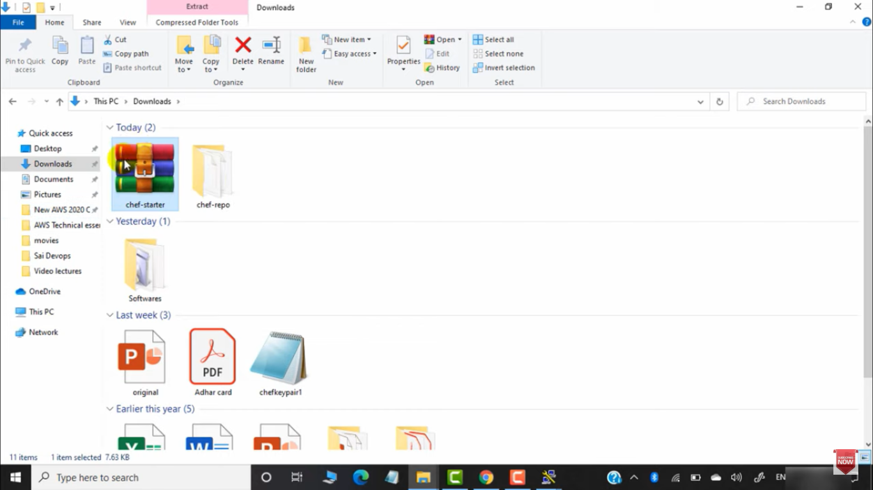

Once downloaded – extrart it to chef-repo

Now winscp th chef-repo to workstation .

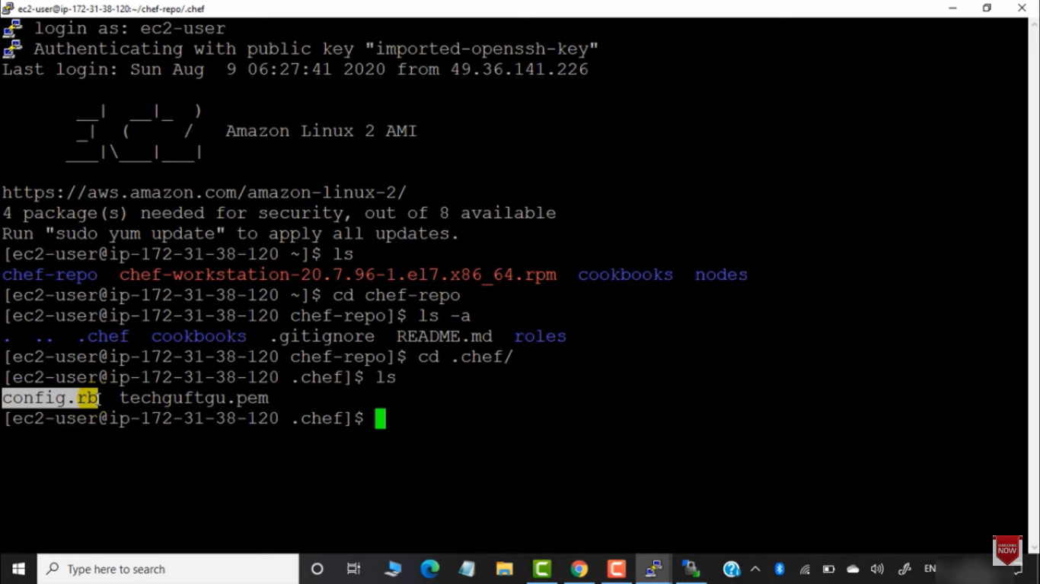

Config.rb - this is knife file

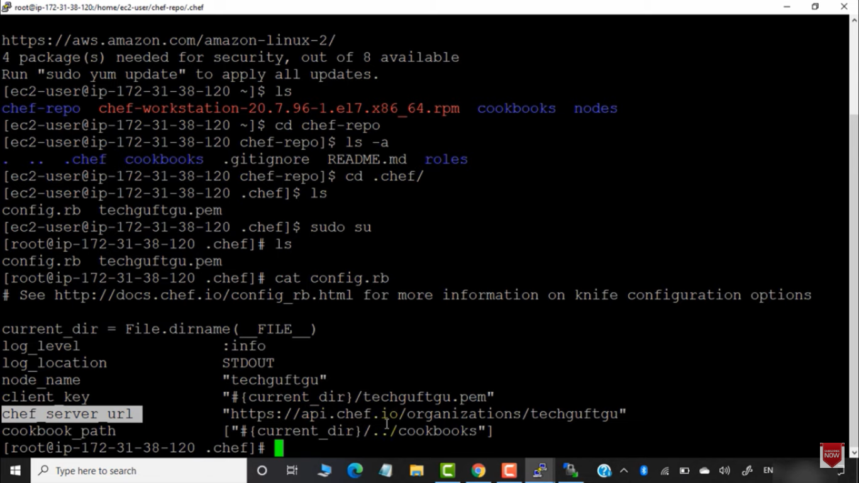

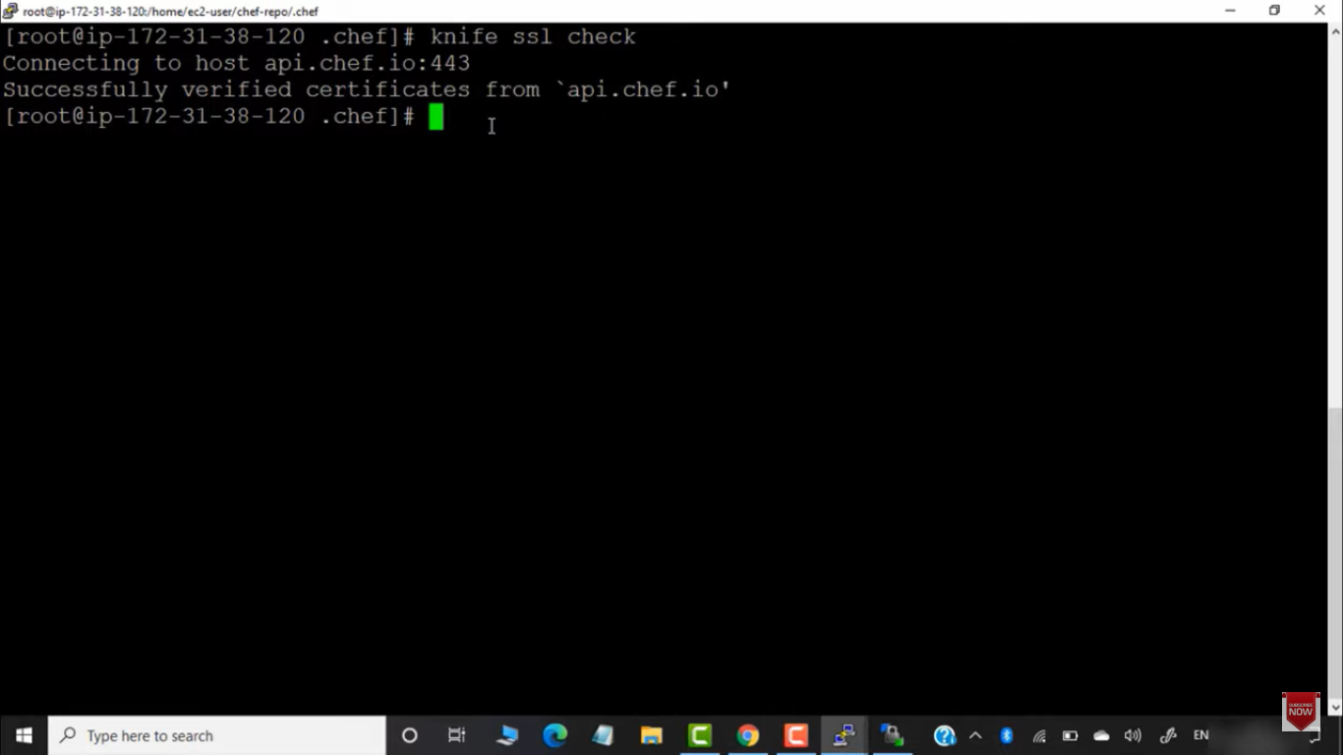

Workstation successfully connected to chef-server .

Now connecting chef-server to node . - bootstrapping

We should use same availability zone for nodes and workstation .

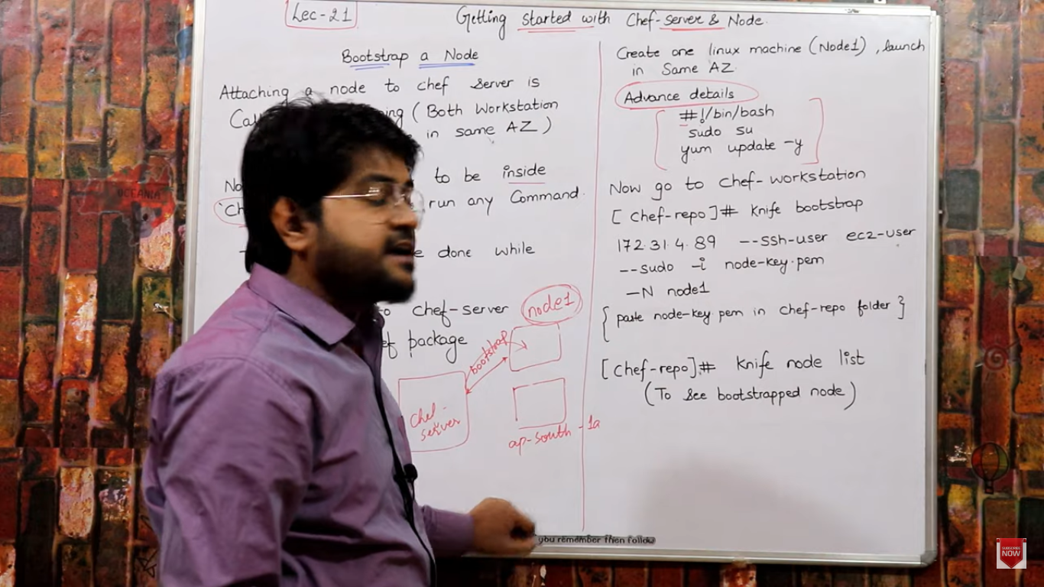

Node-key.pem - this is pem which will be downloaded while we spin up new node .

Create node I same avai;abity zone as workstation .

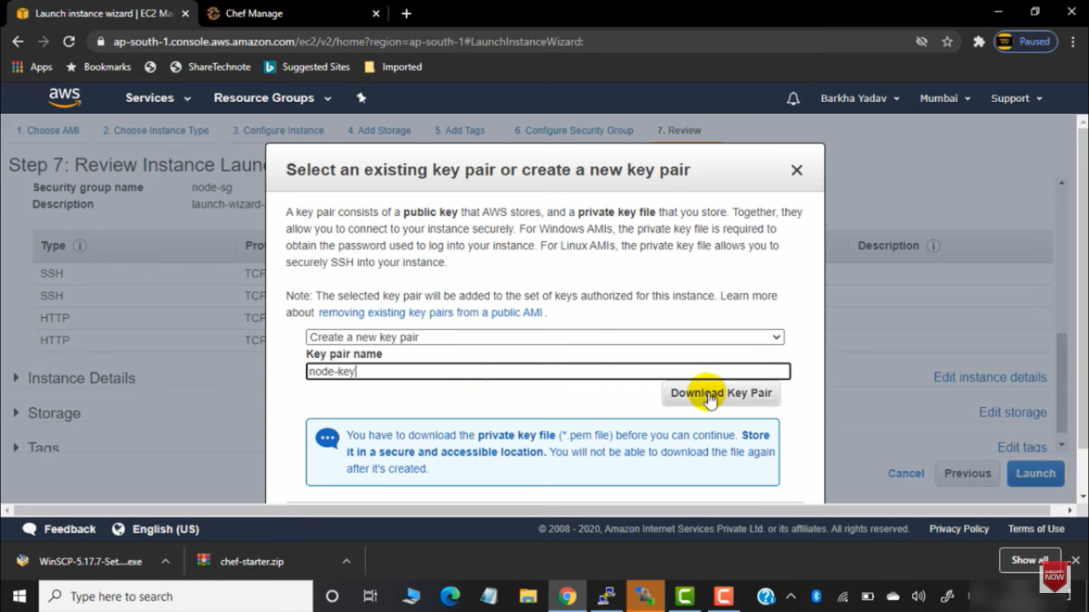

Create key-pair while launching node .

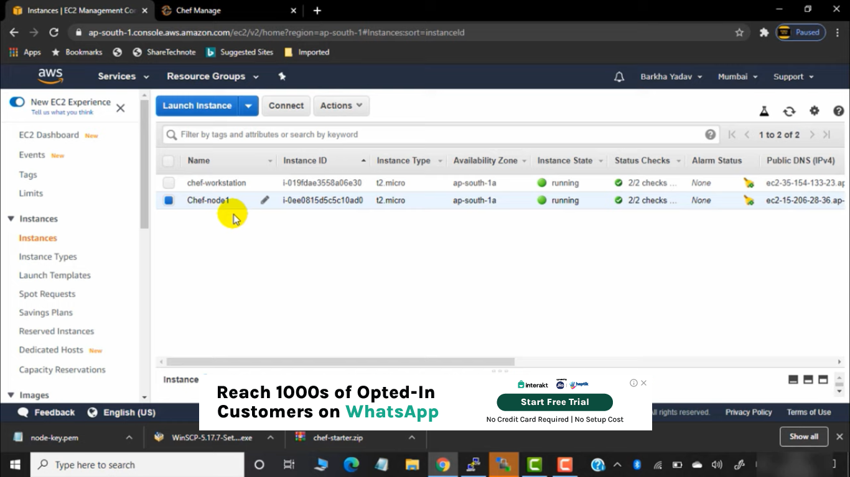Node is created

Now goto workstation

MOve node-key.pem of node server to workstation -> chef-repo floder

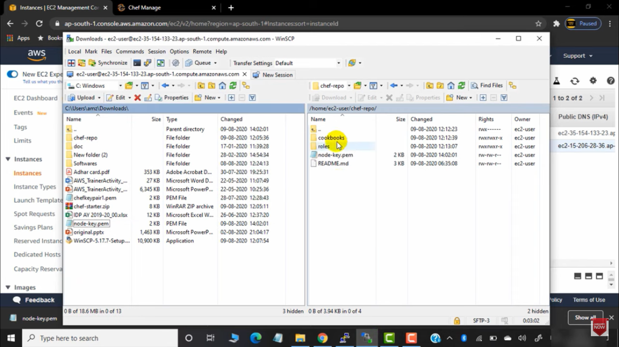

Knife bootstrap privat-ip-node –ssh-user user(ec2user ) --sudo -I node-key.pem -N node1

Above command to connect workstation to node .

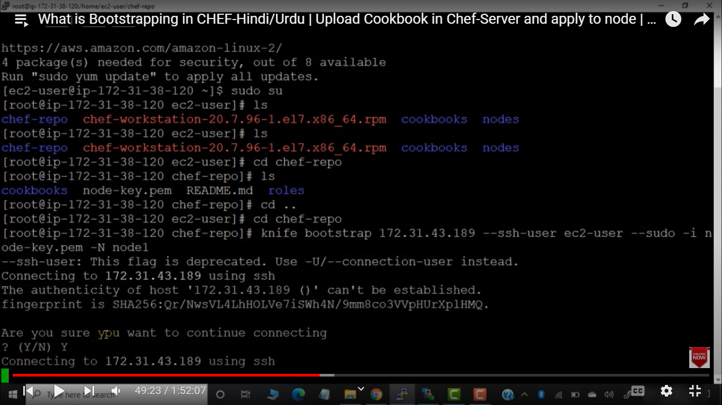

By this node will be connected to chef-server we can also check that by using

Knife node list – command

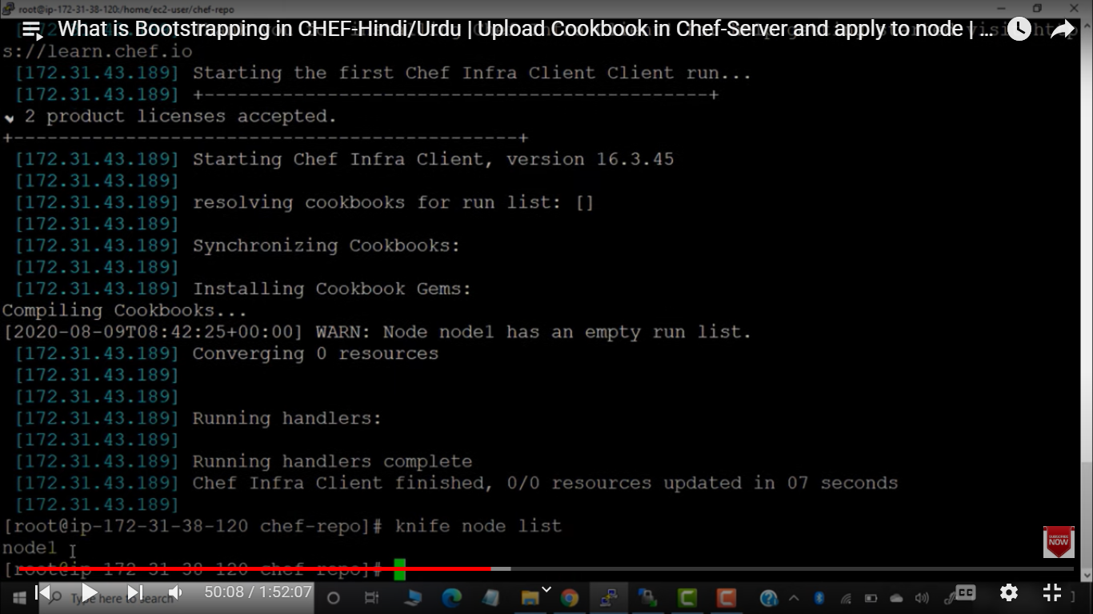

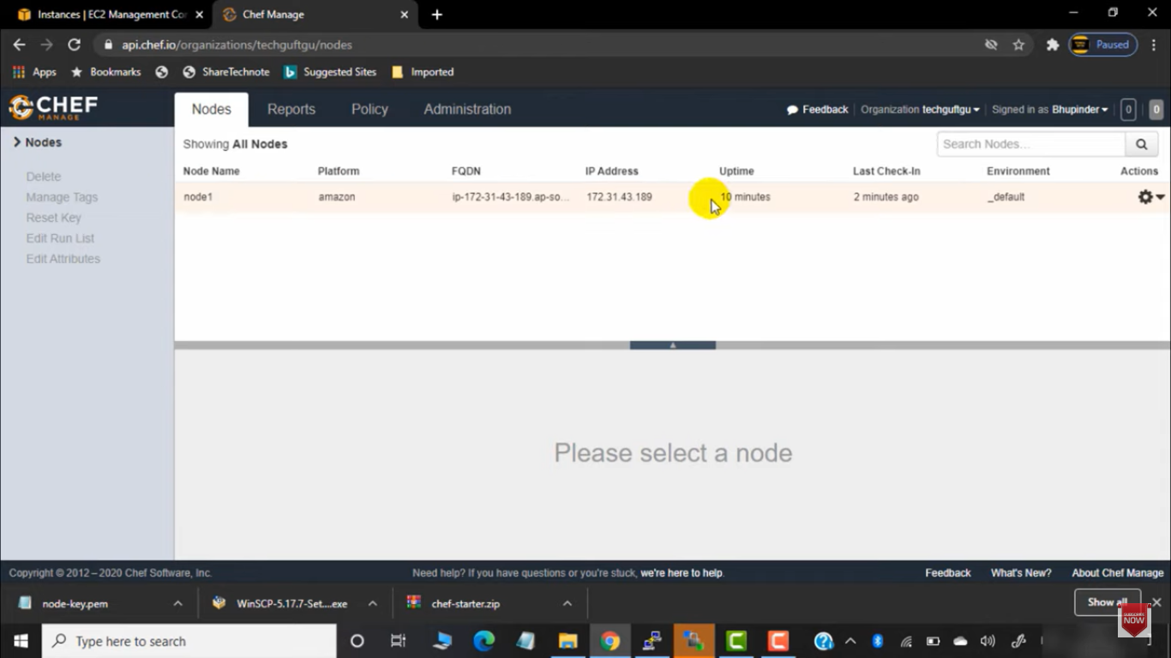

We can check in chef GUI also

In chef-repo w ewill have cookbook dir we will move all our cookbookd to that directory .

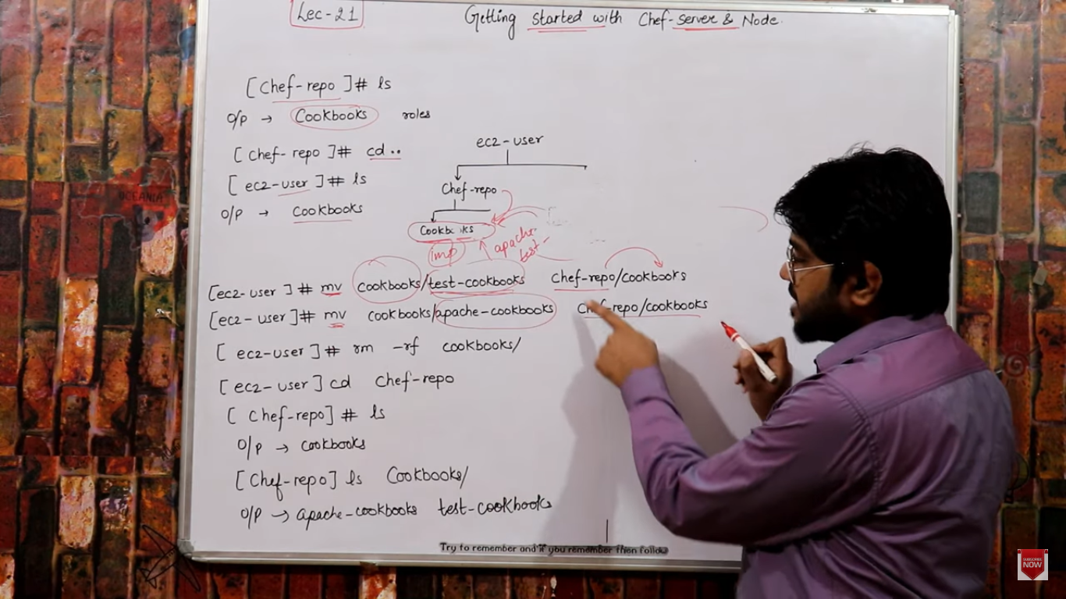

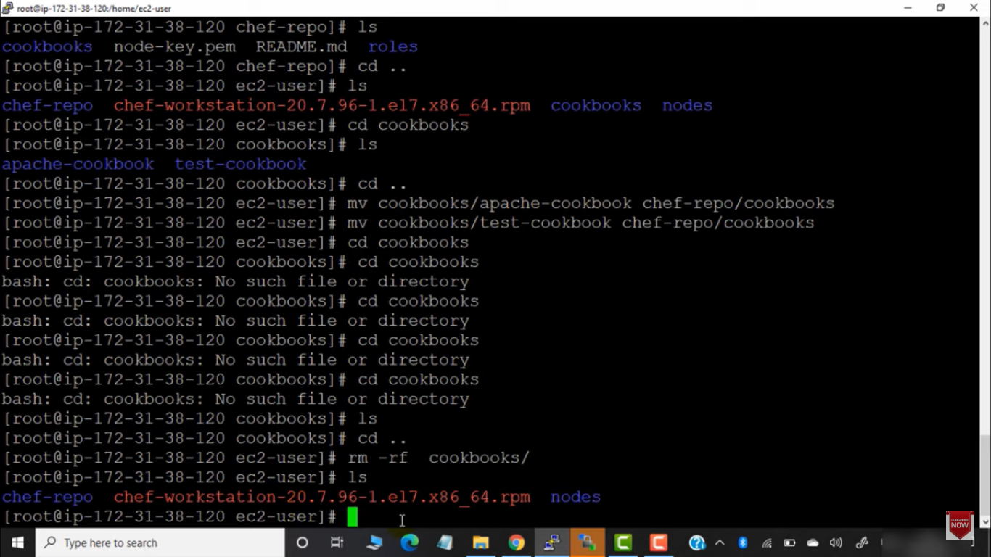

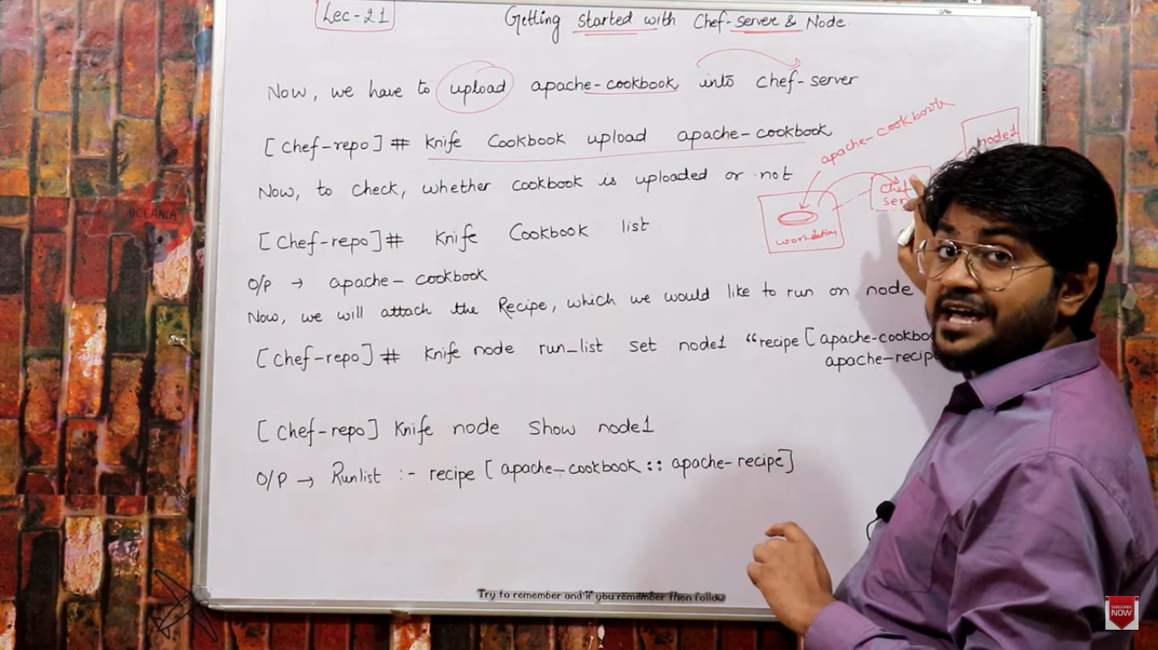

Now we have to move cookbook from workstation -> chef server -> node

Knife cookbook upload cookbook-name – to upload cookbook to chef server .

Knife cookbook list – gives list of cookbook uploaded on server

Knife node run_list set node-name “recipe[apache-ccookbook::appache-recipe]”

This command will add run list (list of recipes) to particular node

For running any recipe in node, we first have to add that recipe to the run-list of node.

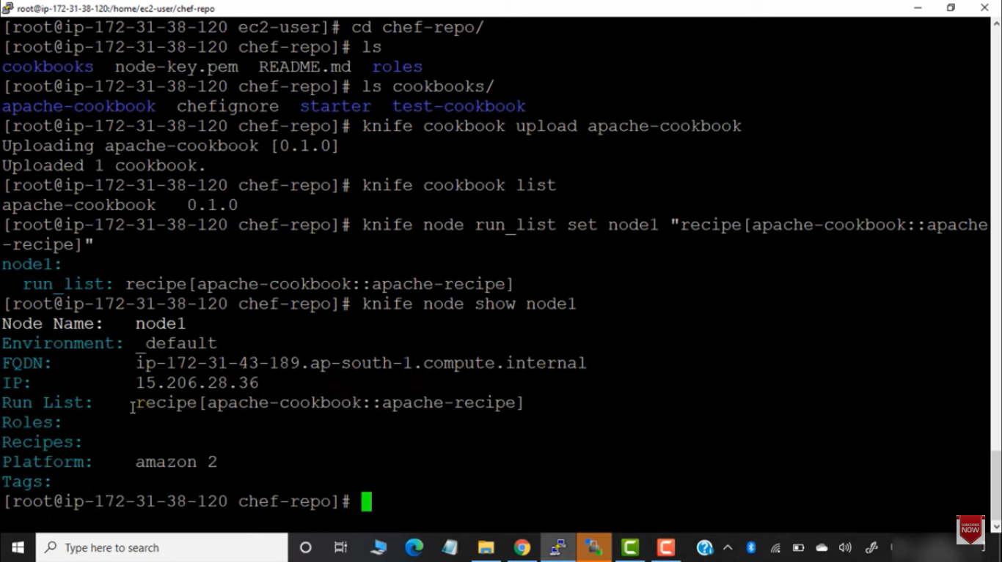

Once runlist added to node we can run chef-client to run recipe in node .

Go to node

Chef-client – this will call the recipe no need to manetion recipe name since node is already conneted to server .

NODE : in below chef-clinet have taken recipe automatically from server .

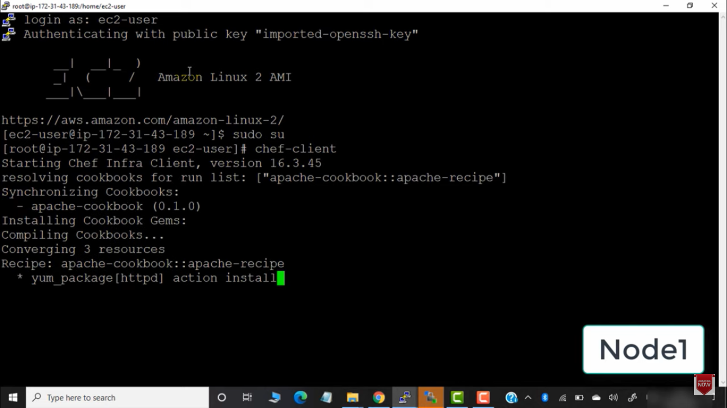

Move to workstation :

Chef-repo > if we update any recipe in workstation . We have to upload that in chef server also usinf knife command .

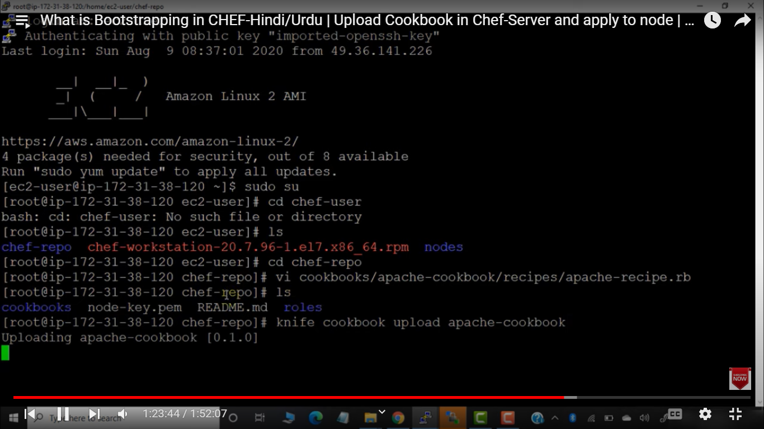

Nnow if we run chef –client in node then it will take updated recipe from server that in upoaded from workstation .

If we don’t want to call chef-client again again in node we can add in crontab .

Vi /etc/crontab

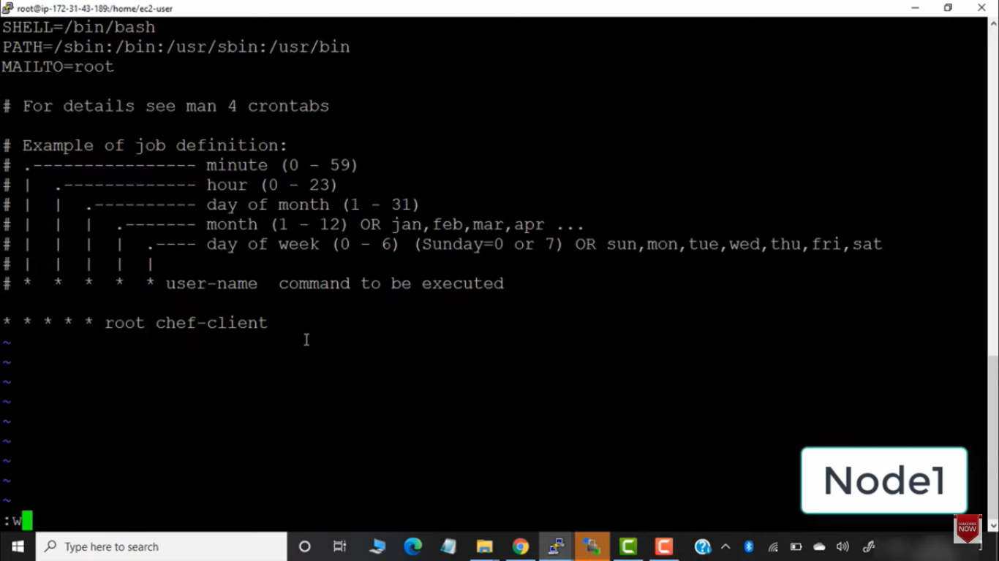

In node set crontab it will automate the inittiation of chef-client on node .

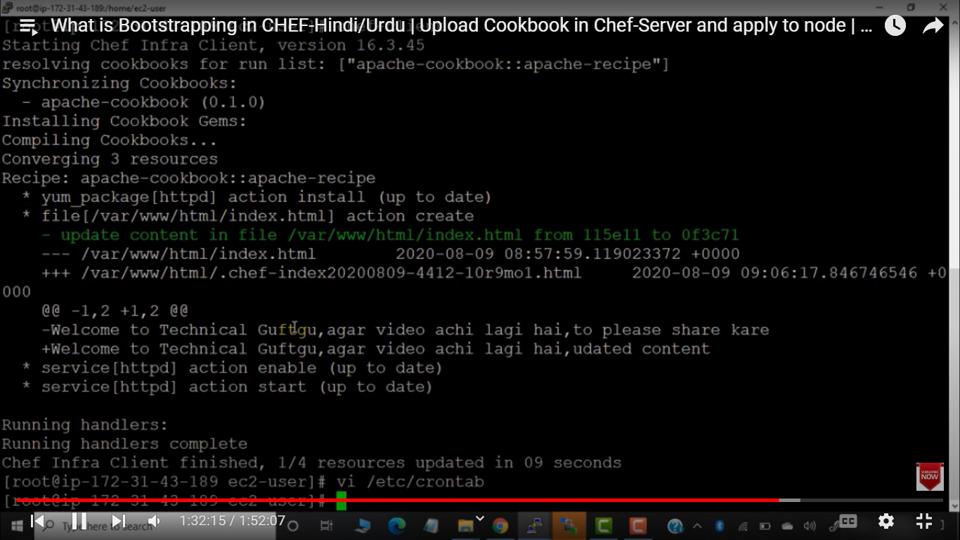

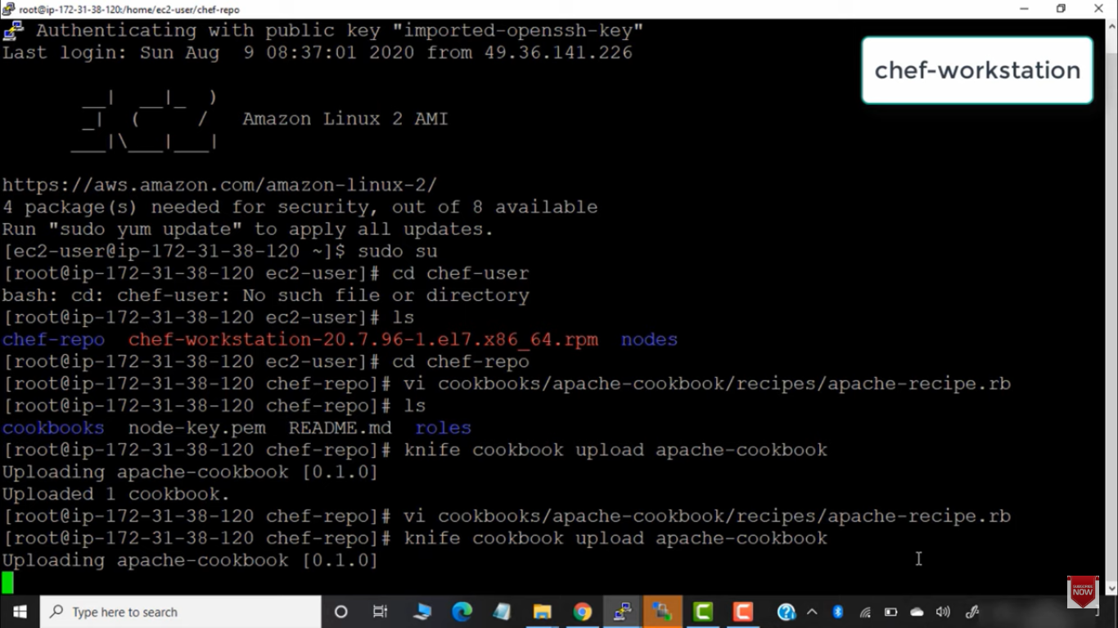

Now we will upload updated cookbook to chef-server using knife cookbook upload .

If we have 100 node and we want to automate we can do that .

Lets create 1 mre node .

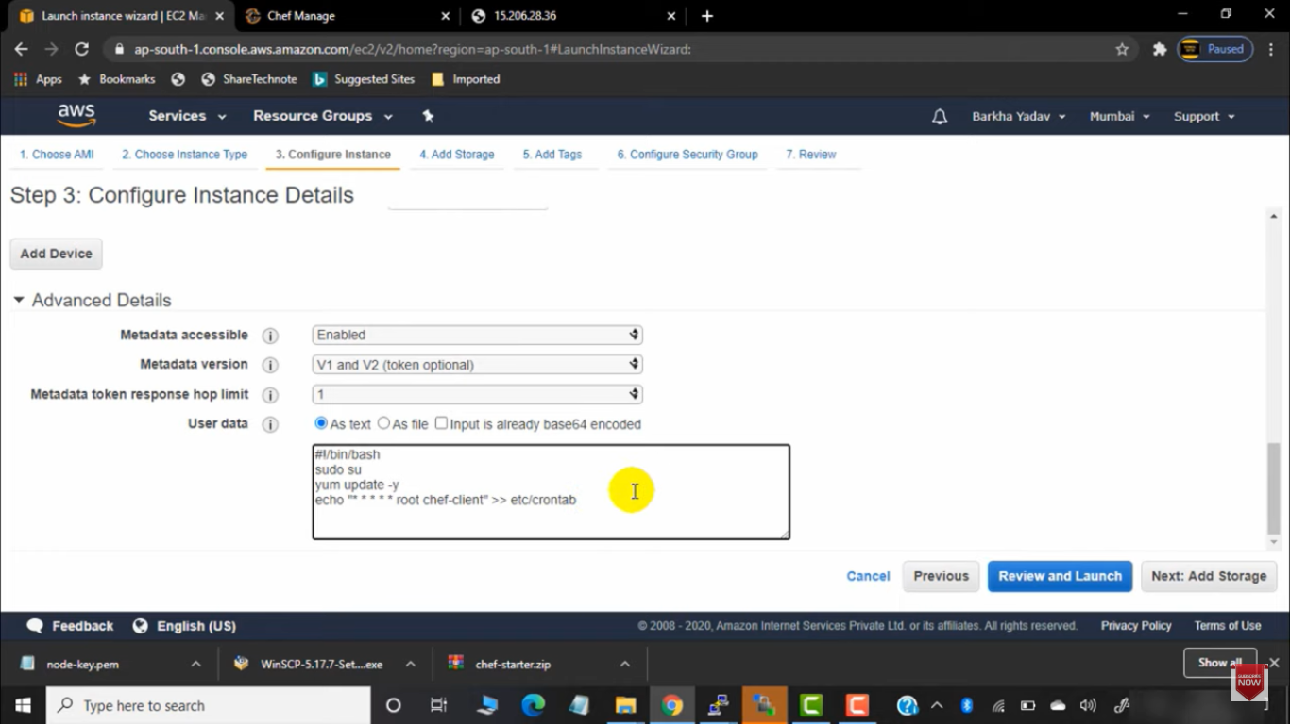

We have given script while spinning instance .

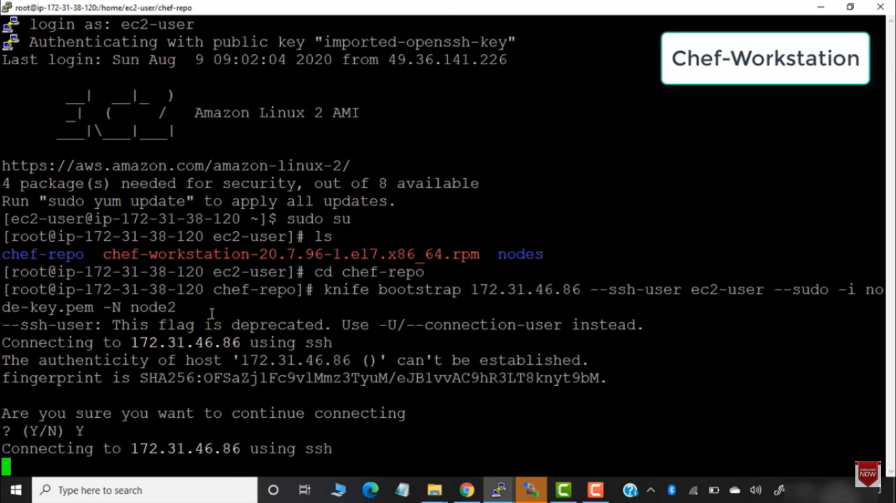

First bootstrap the node with server .

Knife node run_list node2 “recipe”

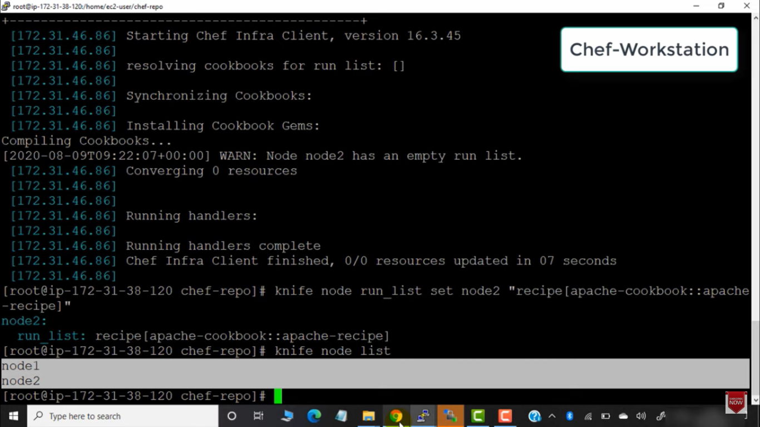

We can add recipe to new node also using knife runlist

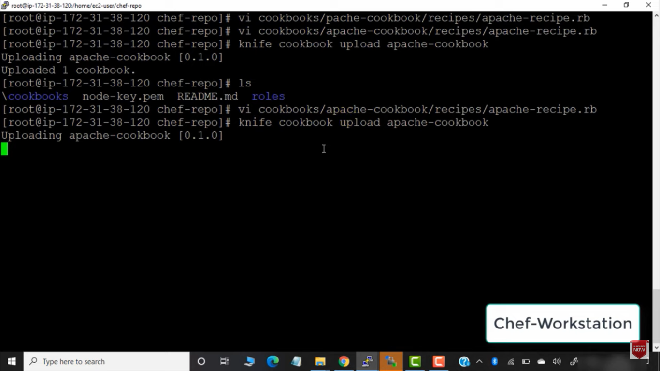

Now if we update the recipe we have to upload recipe to chef-server and the node will automatically take new uploaded recipe

Chef – role

We run runlist command in each node to add recipe to node .

If we create new recipe ad we upload to chef-server , then we explicitly have to add the new recipe in runlist for each node .

So if we have 2000 node we have to add runlist in each 2000 nodes ,

We will automate this task .

Bootstrapping we have to done manaully only .

BUt adding recipe to runlist can be automated .

We can add push notification .

When we bootstrap then chef-client will be created automatically .

Chef-role is used to automate manual runlist addition in nodes .

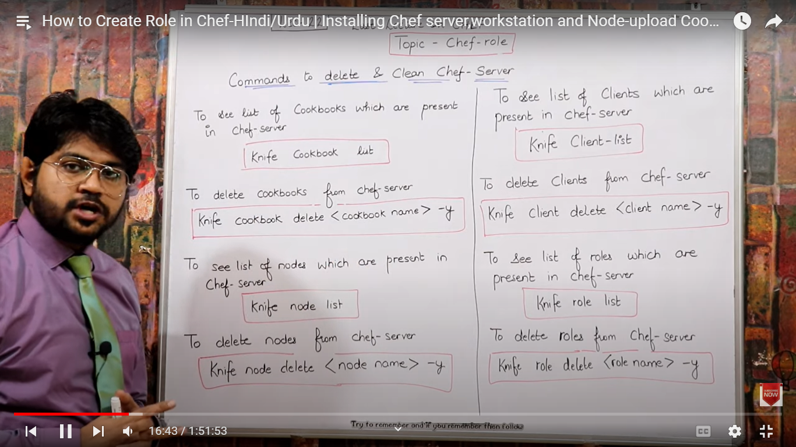

In node we have chef-client and ohai .

Client will be cretaed with the name of node only .

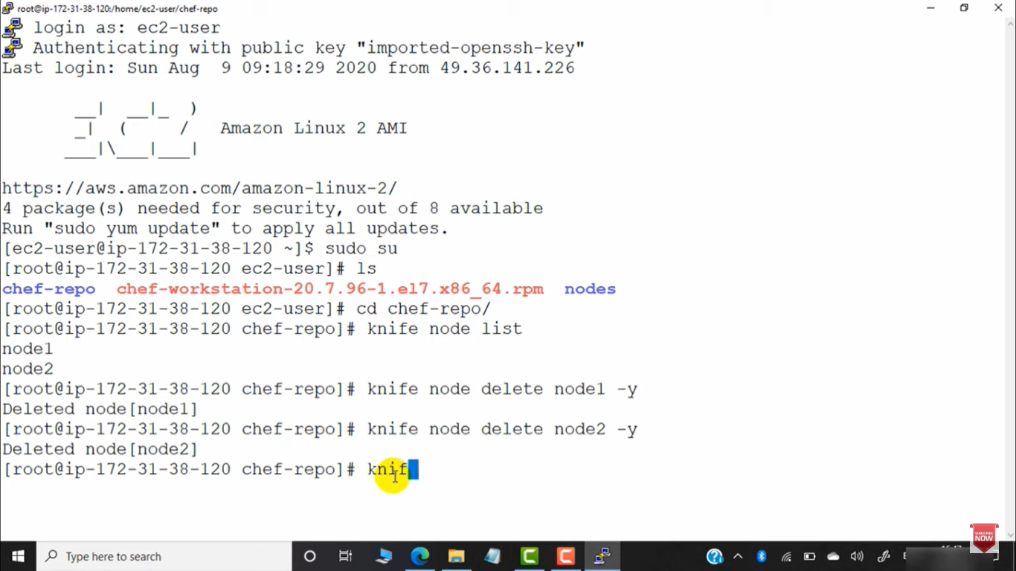

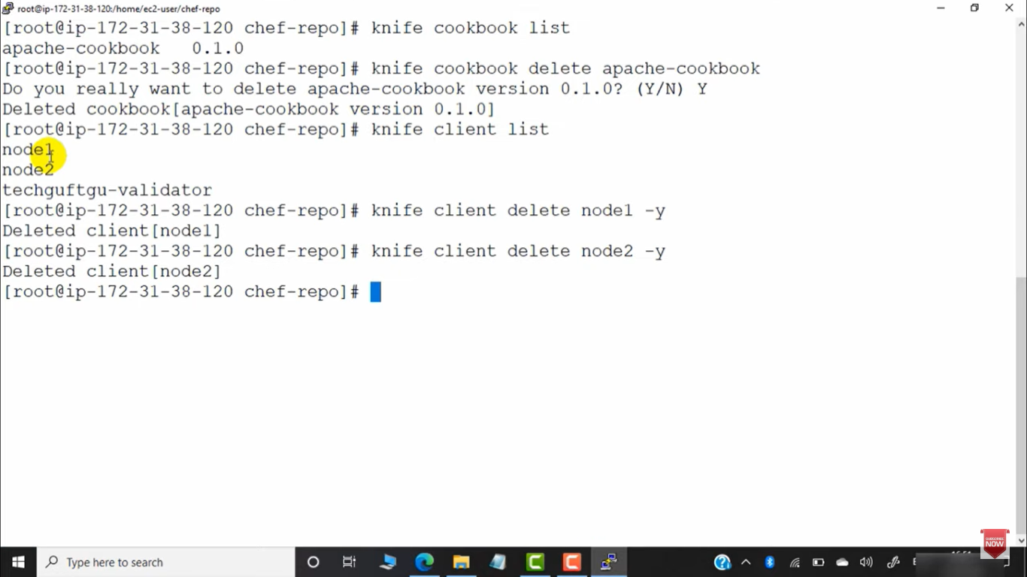

From workstation we can mange nodes and chef-server all .

Suppose we are working on new recipe – and we upload that recipe to chef-server

And create new cookbook in workstation and run that cookbook on node then we have to do runlist command of that cookbook on each node .

So to automate runlist we can create role .

We will create node and do bootstrap of that node .

We will create role in workstation and uplaod role in chef-server ad will conncet role to node .

IN role – we ca create new cookbook . And upload that role to chef –server , so now since role is already add to tunlist of node so ne cookbook of role will be excuted in node .

So In role if we coect new node , then we have to bootstrap that node to chefserver and add role to runlisto of that node so role will be executed in node .

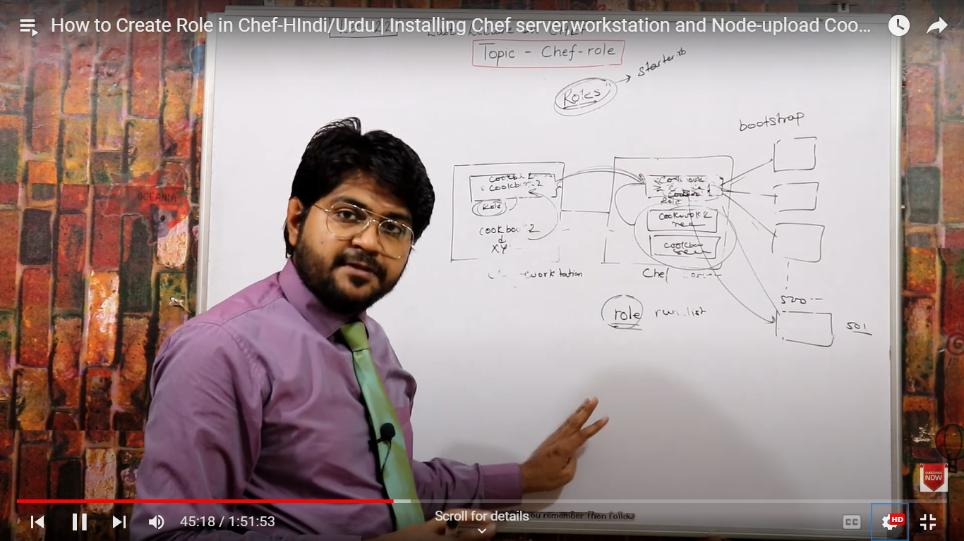

Started.rb - default role .

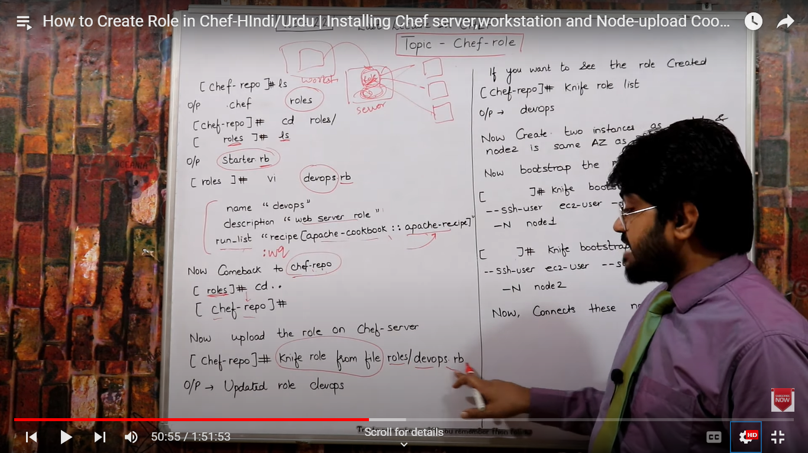

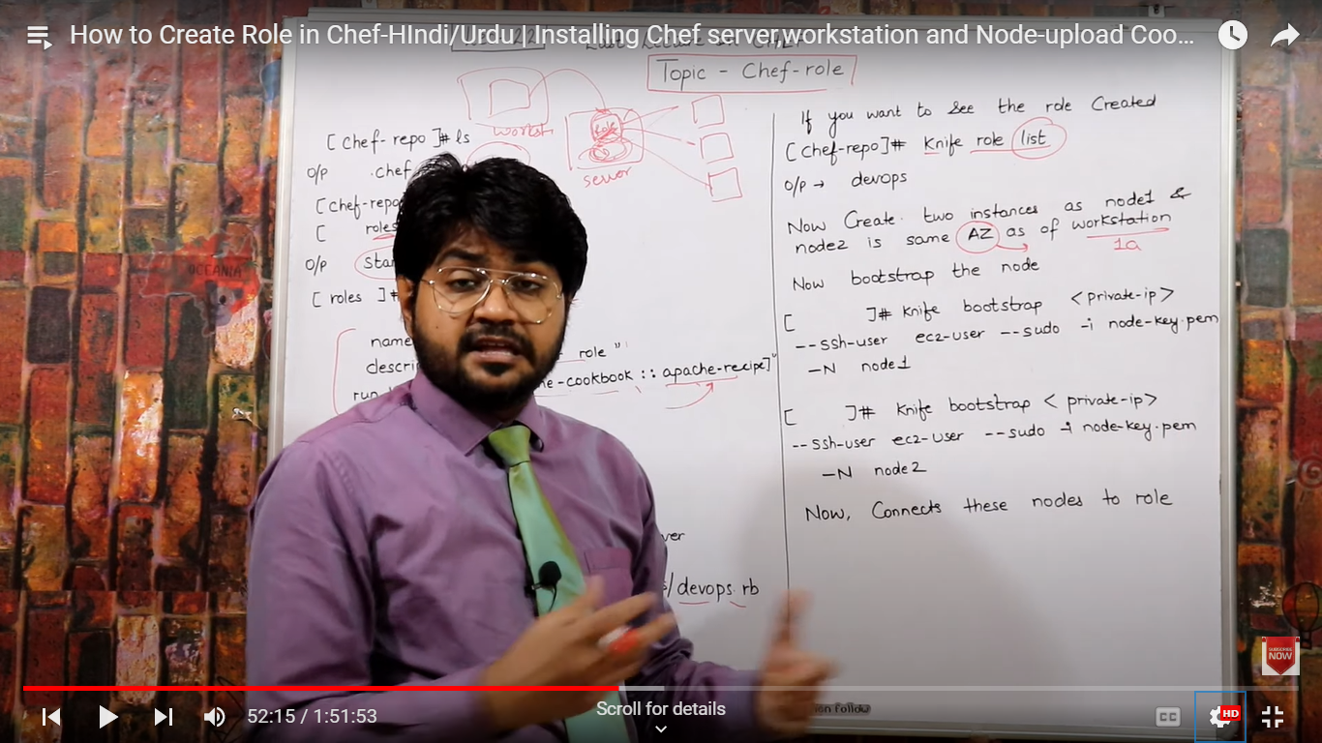

>Knife node list (run in workstation)– gives list of nodes connected to server

Knife node run_list set node1 “role[devps]” - to add role to node run list .

Knife node show node-name > gives list of runlist (cookbook , recipe , roles )

Knide cookbook upload cookbook-name – to upload cookbook to chef server .

We can change recipe of roles .

Knife role from file roles/role-file.rb - to uplaod role to chef-server .

Cookbook k saath recipe name die to bs vo recipe uplaod hofi node m agr sirf role dia to poora role upload hoga server m

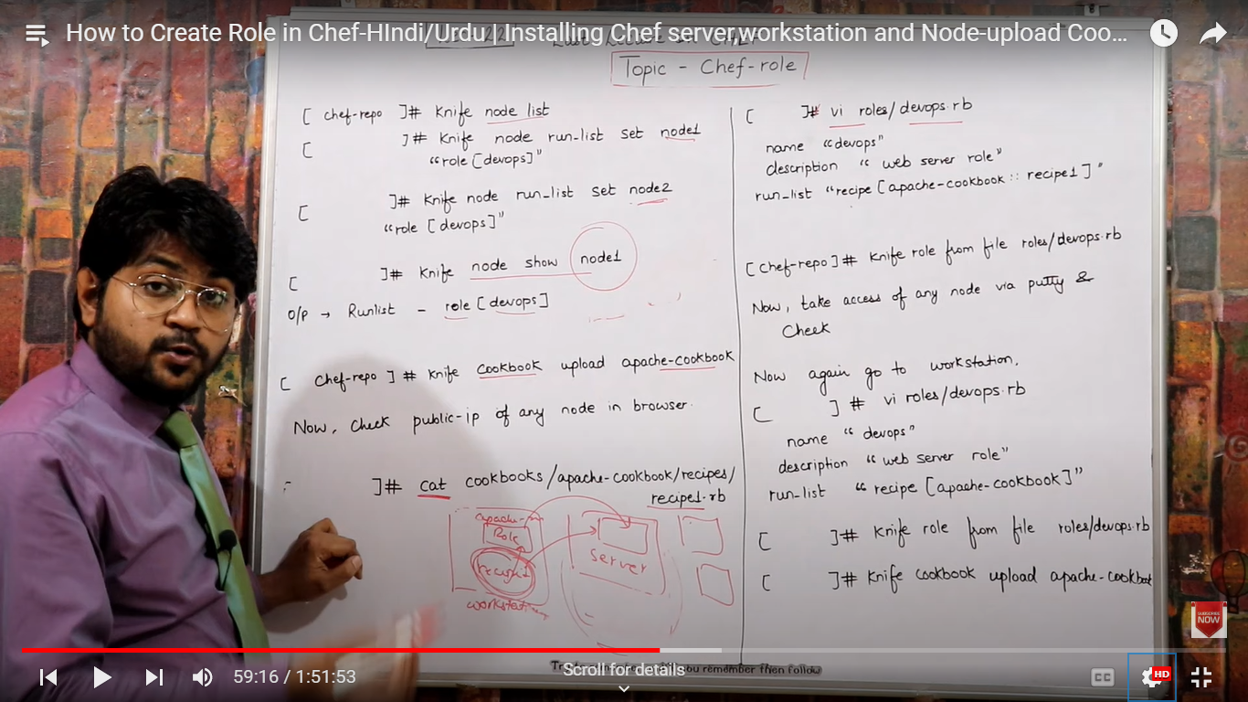

we can uplaod mutiple cookbook to noe usinf role

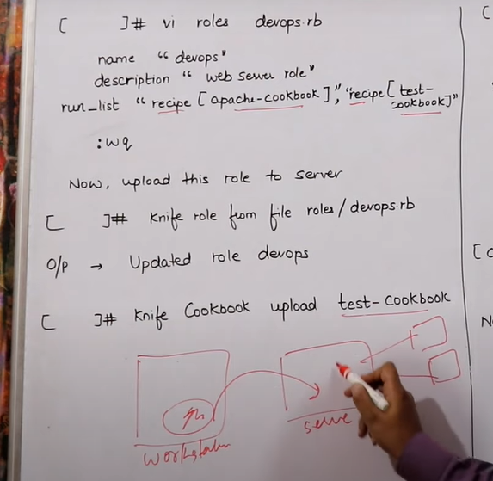

If we have to install 500 softwares at once in server .

Then we can use

%w(httpd mariadb-server git etc pachage-names )

.each do |p|

Package p do

Action : install

End

End

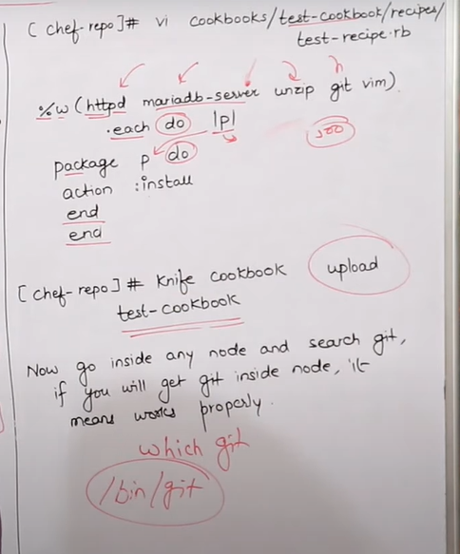

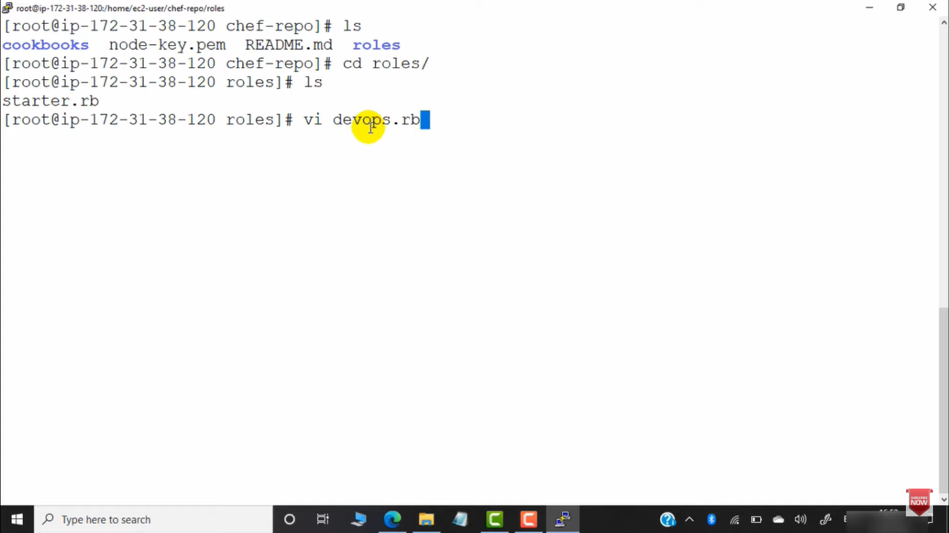

Creating role to add 1 cookbooks recipe to role :

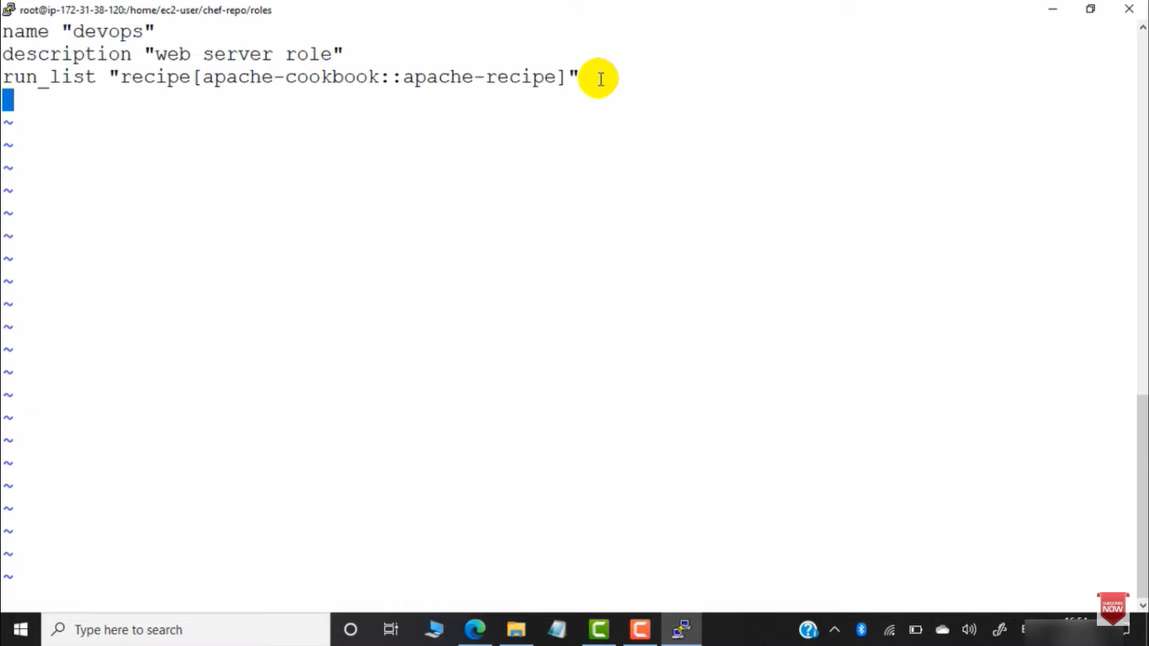

Upload role to server

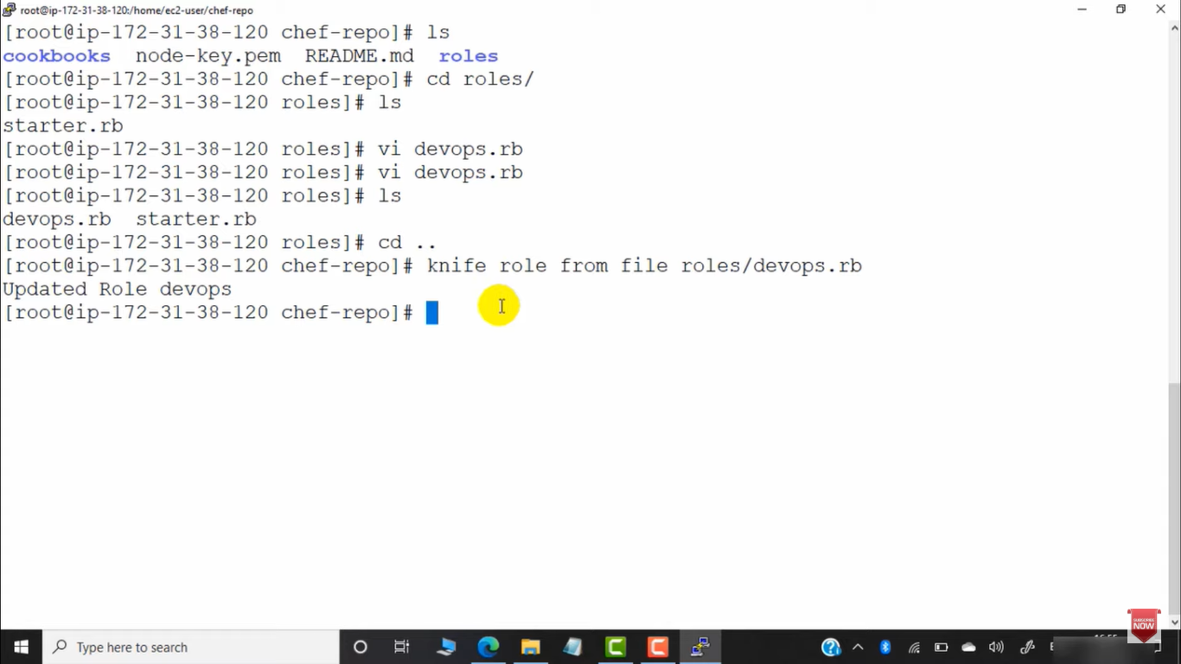

To check whether role is uploaded to server or not

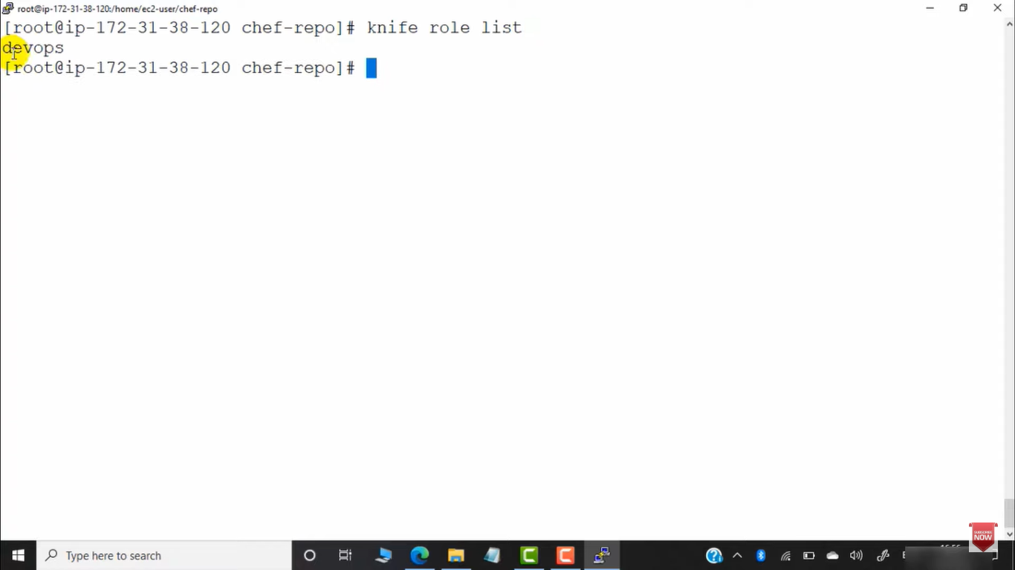

Create new node and bootstarp node to server

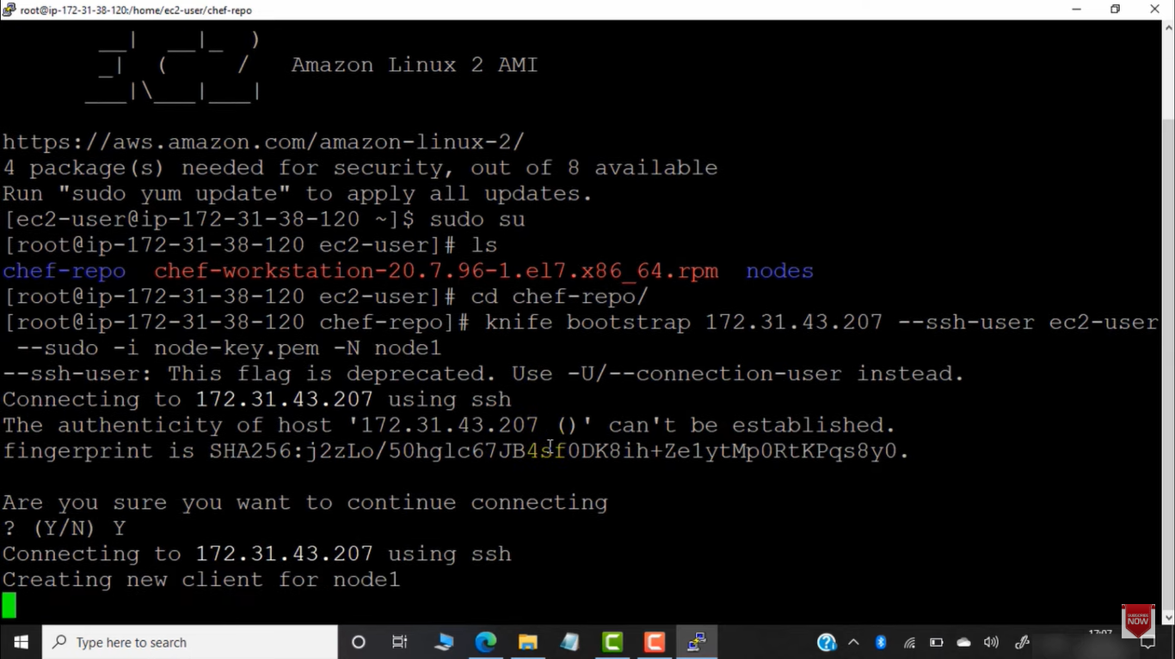

Check all nodes connected to server :

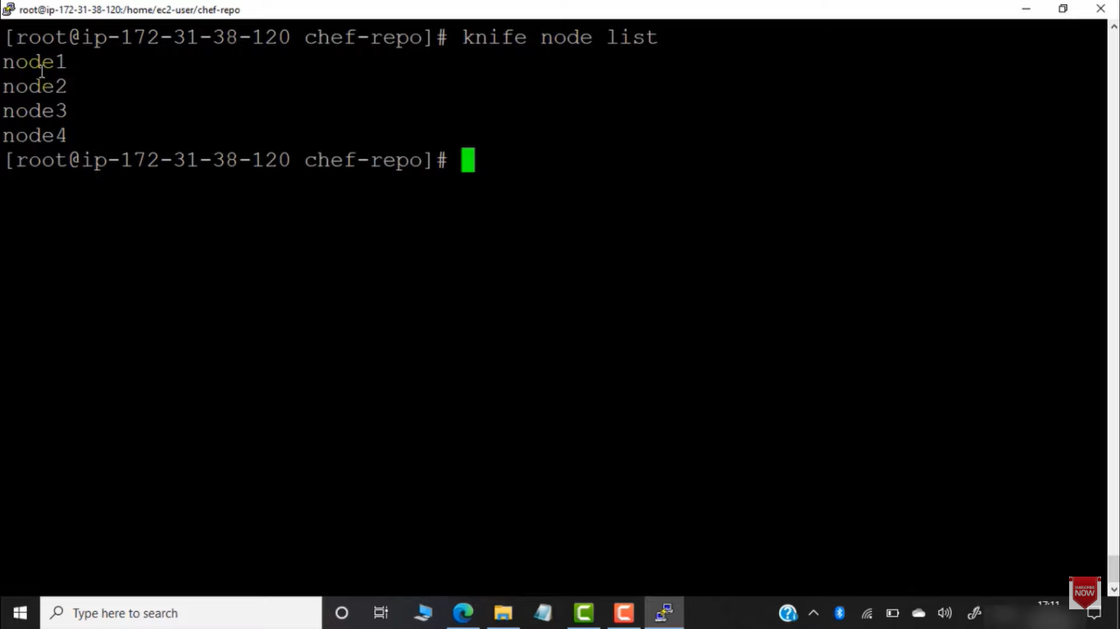

Add role to runlist of nodea and check whther role is added to runlist or not

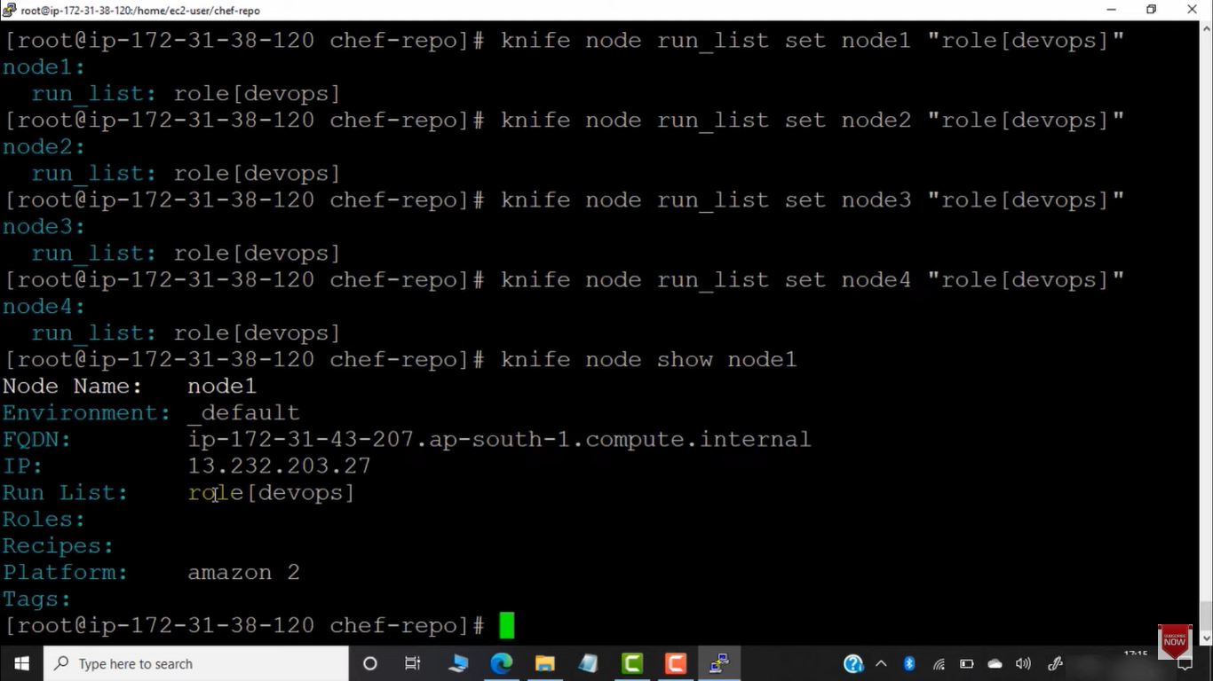

Upload cookbook to chef-server

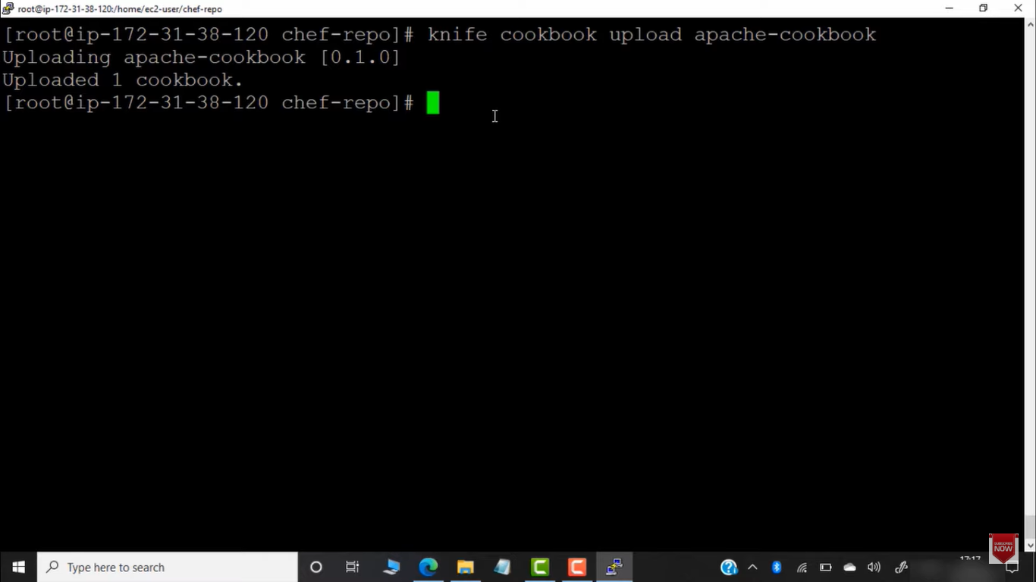

So now this will be trigered by nodes using role .

If we update the role in workstation then we have to uplaod the role again to chef-servr

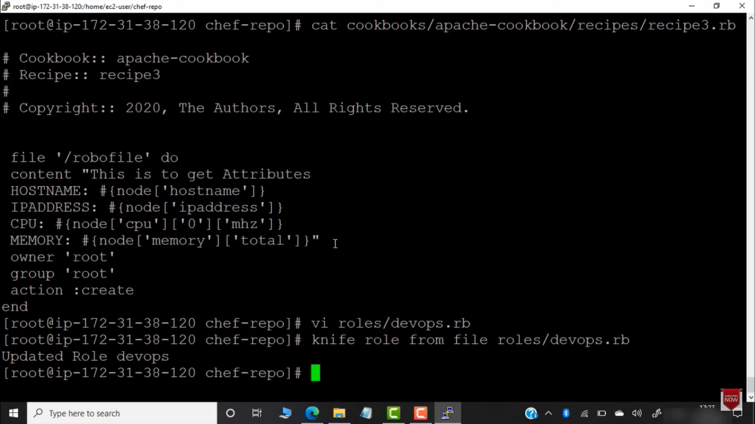

To apply all recipe of 1 cookbook via role

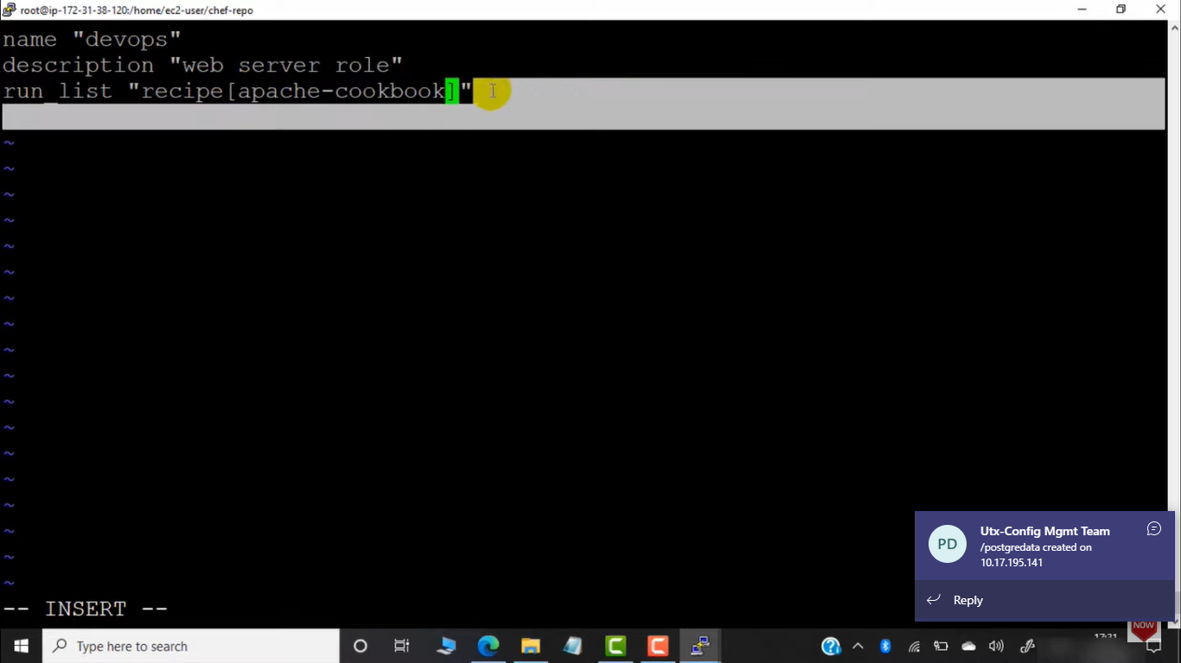

We can make changes to recipe and uplaod role again to chef –server

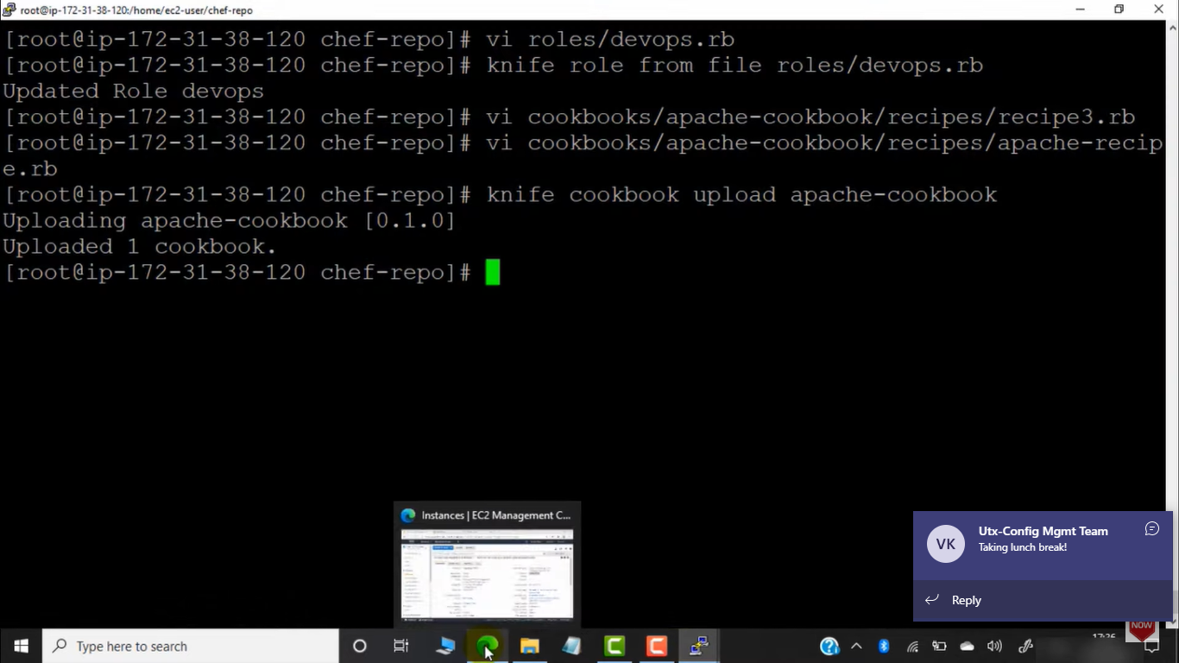

We can add multipel cookbook to role

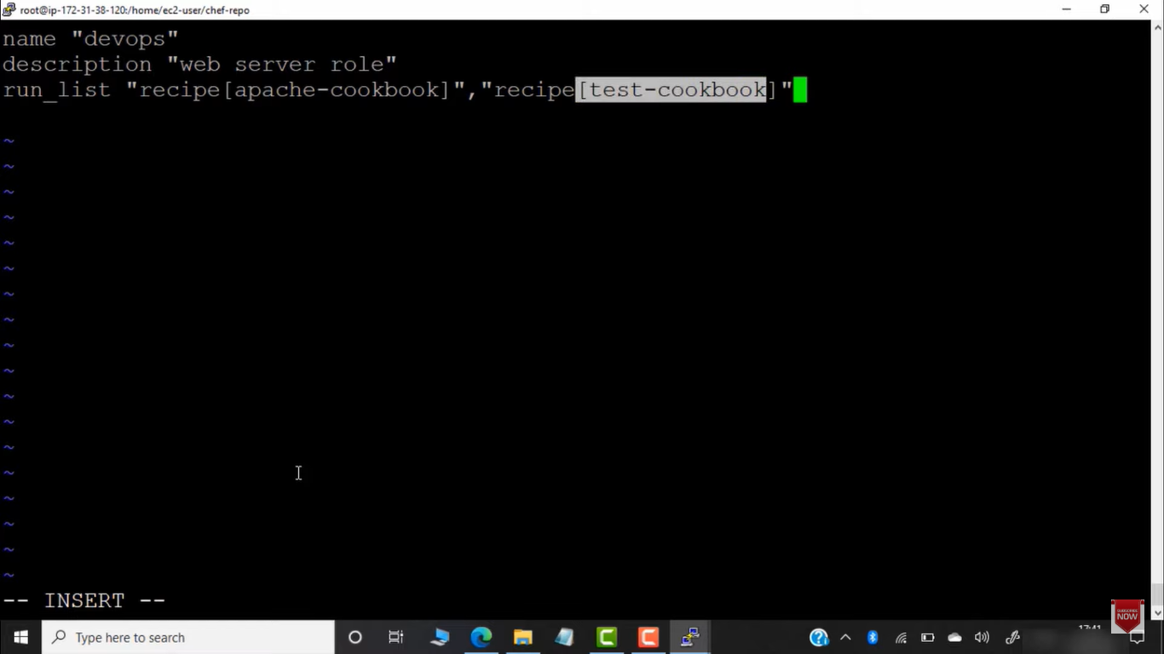

Installing multiple packages to server

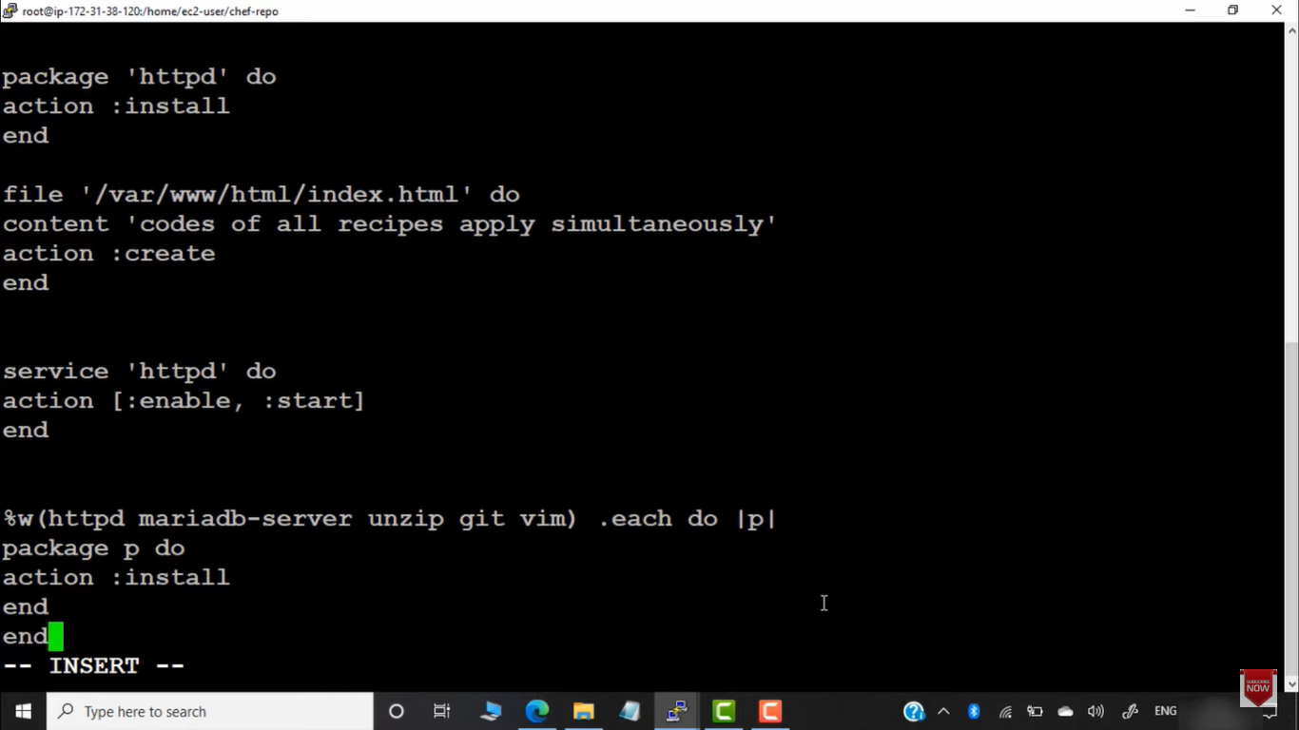

Upload cookbook to server

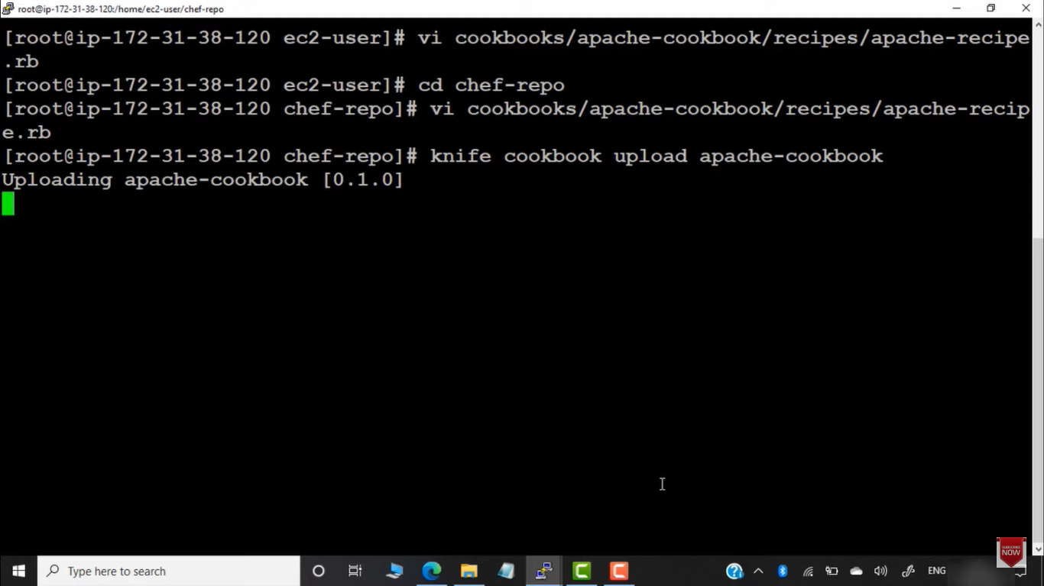

Now the role will be executed in node .

We can delete all nodes

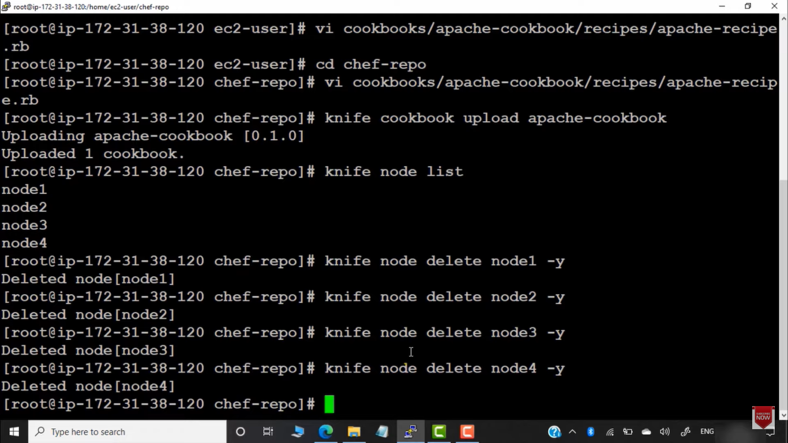

Check list of cookbook in server

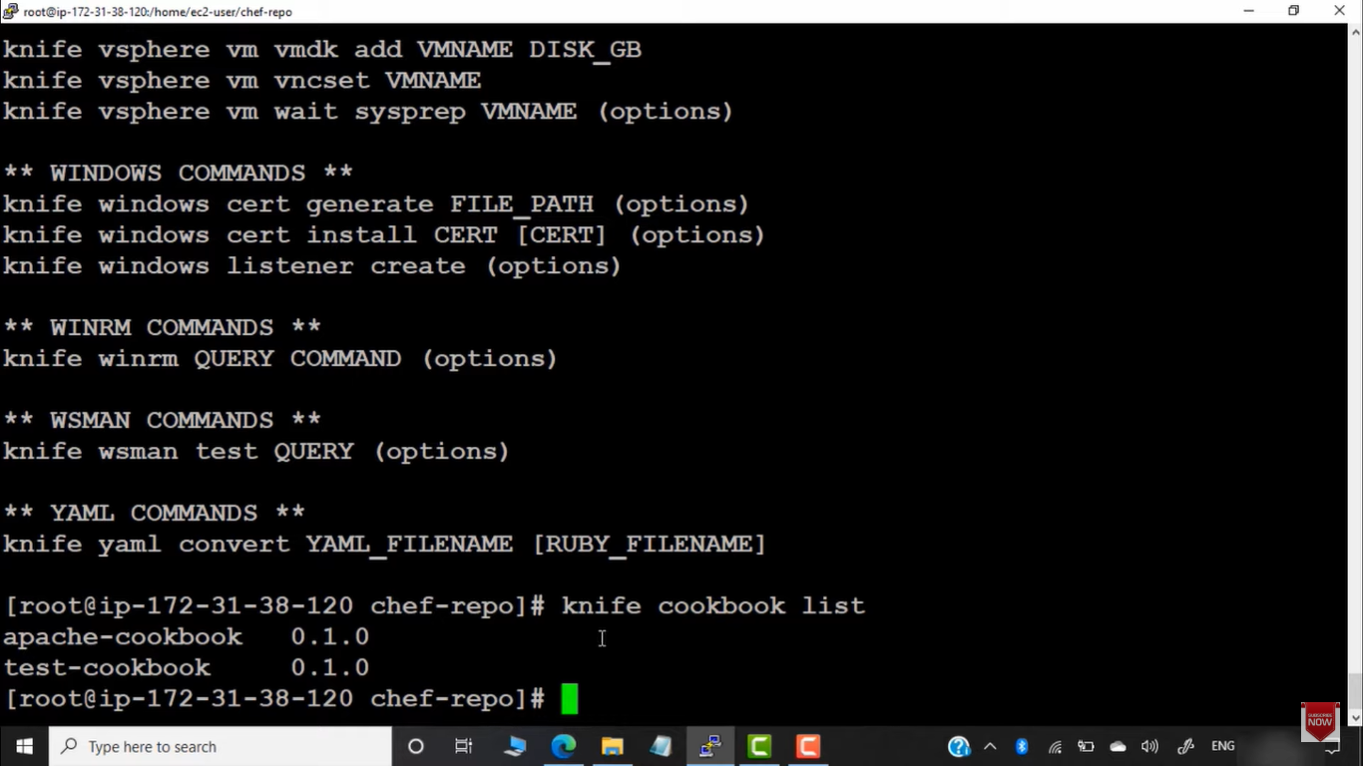

Delete cookbook from server

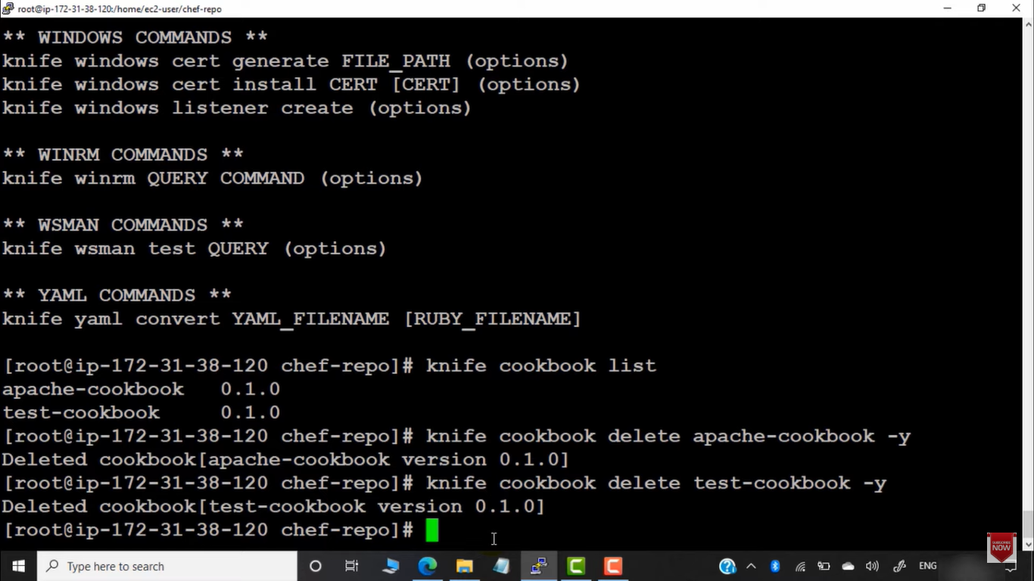

List role and delete role from workstation

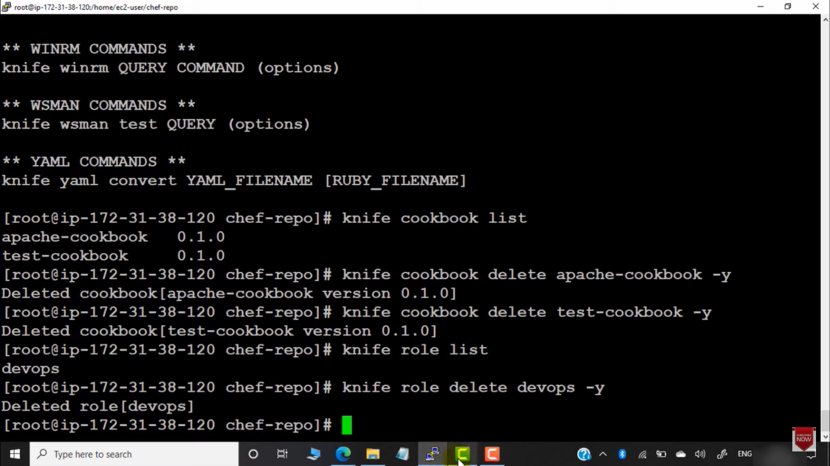

Delete all chef-client

